 2 February 2011

Regional households’ disposable income
Years 2006-2009
Istat disseminates regional accounts for households up to disposable income for the years 2008 and 2009. Regional households’ accounts show the economic behaviour of the Household sector in its crucial steps, from production to disposable income formation in each Italian region. Data are provided at NUTS2 level. Data for 2007 and 2006 have been revised, coherently with national sector accounts published in July 2010 and with regional accounts published in September 2010.

Main results
During the period 2006-2009 households’ disposable income has been concentrating for about 53% in the North area, for 26% in the South and the Islands and for the remaining 21% in the Centre. The North-west area quota decreased from 31.1% in 2006 to 30.5% in 2009, while the Centre quota increased from 20.9% in 2006 to 21.4% in 2009 and the South quota from 25.9% to 26.1%. The North-east one remained unchanged at 22%.
The growth rate of household disposable income progressively reduced from +3.5% in 2006 to -2.7% in 2009. The decline was more evident in the North (-4.1% in the North-West, -3.4 in the North-East), less in the Centre (-1,8%) and in the South and the Islands (-1,2%). This is mainly due to the fall of property incomes, even if in some regions (especially Piemonte and Abruzzo), the decrease of compensation of employees gave an important contribution too (Figure 1).
The decline of North-west households’ income in 2009 is to be imputed to the performance of Piemonte and Lombardia, that alone accounted for 90% of this area disposable income. In Piemonte, in fact, the labour input supplied by employees reduced and therefore their compensation declined. Lombardia, instead, suffered from the drop of profits distributed by enterprises induced by the decrease of their value added.
Households living in the South and the Islands appear to have less suffered the impact of the economic crises. Calabria and Sicilia are the only two Italian regions where household disposable income slightly increased. In the same regions also the GDP dynamic has been better than elsewhere. Southern regions also benefited of the performance of net interests received by households. The lower propensity to risky investments of southern households, while in the previous year retained the growth of property income, in 2009 saved them from the decrease of receivable interest lead by the economic crises (interest rates of less risky asset decreased less). Moreover, the lower debt load of southern households limited the negative impact on gross operating surplus of the increase of intermediate costs for Fisim, caused by the increase of the spread on borrowing rates.
Also in 2008, when the national disposable income increased by 2.3%, North-West recorded the lowest growth rate (+1.8%), because of feeble growth in Lombardia and Liguria (+1.2% and +1.8%). In this year, instead the North-East, displayed the most relevant increase: this is the area where the regions experienced a faster growth: Friuli-Venezia Giulia, Veneto and Trento (+5%, +4.3% and +3.6% respectively). At the same time Centre and South and the Islands raised similarly to national average (+2.5 and 2.2 respectively). The highest growth rate in the Central area is recorded for Lazio (+2.9%), the highest in the Southern area are displayed for Abruzzo (+3.4%) and Basilicata (+3.1%). The regions where household disposable income showed the weakest growth are in the South: Molise (+ 0.8%) and Calabria (+1.1%).

Figure 1 - Contribution to households’ disposable income growth rate – Year 2009

Figure 2 - Contribution to households’ disposable income growth rate – Year 2008

Figure 3 - Contribution to households’ disposable income growth rate – Year 2007

Up to 2008, households living in the North-western regions recorded the highest per capita disposable income, but in 2009 the North-eastern regions topped the list, and Bolzano ranked first, overtaking Emilia-Romagna. During 2009 per-inhabitant disposable income of southern regions decreased less than in the other areas, converging to the national average. Nevertheless, differences in levels of per capita disposable income remain significant: northern regions still recorded the highest levels and the southern regions the lowest, while the central regions were in an intermediate position. The only exception was Toscana, which was closer to Northern regions levels (Figure 4).
Figure 4 - Disposable household income per inhabitant - Year 2009

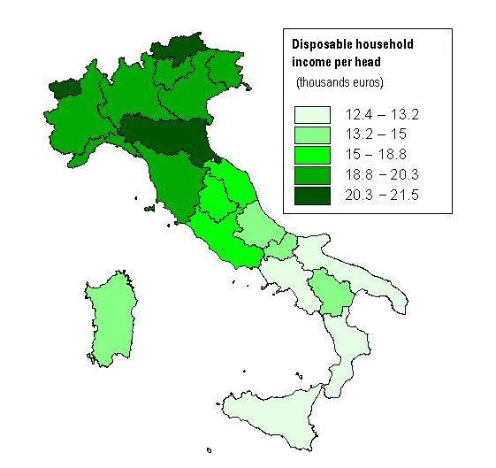

Table 1 – Households’ disposable income. Main aggregates by regions and area -Year 2006 (millions of euro)

Table 2 – Households’ disposable income. Main aggregates by regions and area - Year 2007 (millions of euro)

¹ National total does not include economic activities not ascribable to specific territory (ex: Italian embassies abroad, sea oil rig).
(*) Property incomes include the flows of mixed income transferred from producer to consumer unit. The national balancing item of this flow is zero, while at a regional level it is determined by the difference between the residence of the productive unit and the one of its owner. Interests included in this flow are corrected for Fisim.

Table 3 – Households’ disposable income. Main aggregates by regions and area - Year 2008 (millions of euro)

Table 4 – Households’ disposable income. Main aggregates by regions and area - Year 2009 (millions of euro)

¹ National total does not include economic activities not ascribable to specific territory (ex: Italian embassies abroad, sea oil rig).
(*) Property incomes include the flows of mixed income transferred from producer to consumer unit. The national balancing item of this flow is zero, while at a regional level it is determined by the difference between the residence of the productive unit and the one of its owner. Interests included in this flow are corrected for Fisim.

Contact person:
National Accounts Directorate
ISTAT – Italian National Institute of Statistics
Via A. Depretis 74b – 00184 Rome, Italy
Francesca Tartamella
ph. +39 06 4673.3128

Statistics in brief - Annual non-financial accounts (1990-2009) published on: 22 July 2010 (http://en.istat.it/salastampa/comunicati/non_calendario/20100722_00/).
Statistics in brief - Regional Accounts (year 2009), published on: 28 September 2010 (http://en.istat.it/salastampa/comunicati/non_calendario/20100928_00/).
We remind that compensation of employees received by resident households do not completely overlap with compensation of employees displayed in regional accounts which are recorded according to employers residence.
Services offered by financial intermediaries that do not have an explicit price, but are indirectly paid for by the spread between rates applied to savers and borrowers.
Wide differences in size and population of the Italian regions makes it meaningless to compare the total amounts of disposable income, comparisons are normally expressed in terms of amounts per head of the population.

