Travel-to-Work Areas: the 2007 review

Mike Coombes
CURDS
(Centre for Urban & Regional Development Studies in Newcastle University)
and
Steve Bond
ONS
(Office for National Statistics)

Acknowlegements
The authors acknowledge that this research could not have been undertaken without the input of Colin Wymer (freelance researcher in Newcastle); all the maps in this report were produced by Simon Raybould (CURDS).
The 2001 Census dataset used in this research is Crown Copyright (but not in the public domain).

Synopsis
This is the Final Report from research undertaken in CURDS for ONS as part of the process leading up to the 2007 definition of revised Travel-to-Work Areas (TTWAs). The task for the research was to review the TTWA definition method and to analyse the 2001 Census data, so as to define the maximum possible number of separate TTWAs that satisfy appropriate statistical criteria; these criteria ensure the TTWAs meet all the relevant guiding principles for labour market area boundary definitions. In this report there is an explanation of the background to these principles, a review of the opportunities open to the research, an exposition of the innovations in the definition method and visual insights into the way the method works, some analysis of the results’ sensitivity to changes in the method or statistical criteria, a summary of the geographical and statistical characteristics of the new TTWAs, and a brief evaluation of the research and some possible ways in which it could be extended.

ISBN 978 1 85774 676 1



Executive Summary

This report covers research for the revision in 2007 of Travel-to-Work Areas (TTWAs). TTWAs are designated by the Office for National Statistics (ONS) as a statistical geography that represents a set of sub-regional labour market areas which is identifiable as patterns of commuting. These patterns change over time so TTWAs are reviewed each decade with Population Census commuting data. This report summarises the research leading to the definition of 2001-based TTWAs.

TTWAs serve the following areas of policy need:
- inform inward investment
- monitor the effectiveness of labour market programs
- frame labour market analysis (eg. on local labour supply/demand spatial mismatch)
- provide the smallest area for which workforce-based rates can be compared
- offer a statistically consistent geography for the whole country
- provide a comparable definition of each city's local economy.

The value to statistics users of the 2001-based TTWAs is that they make possible more valid comparisons of labour market conditions across the country. In addition, they have one key advantage over local authorities (which are the ‘default’ set of areas for local data) in that they offer more local detail in areas like the Highlands of Scotland where seven separate TTWAs provide local evidence that is ‘averaged away’ by statistics for the single local authority area.

The 2001-based TTWAs have evolved from their predecessor in 1991 due to new developments in Census data and changes in the policy requirements for TTWAs (specifically allocation of European Structural Funds were made using 1991-based TTWAs). The key changes to the data are: 100% coverage in 2001 as opposed to a 10% sample in 1991; data aggregated to the smaller LSOA geography in 2001 compared to wards in 1991; a relaxation of the requirement for TTWAs to not span national borders. These changes along with improvements in computing power have led to a simplified method of producing TTWAs for the 2001 data compared to the 1991 predecessor. The improved data and processing have led to marked improvements in the TTWA definitions.

The TTWAs created by the computer were tested in many ways including consulting with local experts to ensure the creation of the maximum number of distinct areas satisfying the required statistical criteria of working age population and self-containment of labour. The end result is 243 distinct TTWAs which conform, in most areas, to recognised local labour market patterns (ranging from parts of the country with large dominant cities to areas with a more polycentric pattern of several closely spaced towns of a similar size).

Objectives

Travel-to-Work Areas (TTWAs) are designated by the Office for National Statistics (ONS) as a statistical geography. TTWAs are the output from consistently applying one approach to defining sub-regional labour market areas. The geography of labour markets which TTWAs represent are identifiable as patterns of commuting. These patterns change over time so TTWAs are reviewed each decade when there is new information available in the form of Population Census commuting data. This report summarises the research leading to the definition of 2001-based TTWAs.

Statistical geographies need their boundaries to be defined as consistently as possible, otherwise the reported statistics can give a distorted view of the reality underlying them. The underlying logic is a statistical argument about using appropriate classifications which, in this case, means an appropriate geographical classification (cf. Rose & O’Reilly 1998). For several decades now, each new Census has led to a review of TTWAs with the explicit objective of providing a consistently defined set of appropriate areas for reporting local labour market statistics in general, and unemployment statistics in particular.

Before the 2001 Census dataset was available, ONS consulted key stakeholders and other users of TTWAs to assess the need for a review. Reasons for needing TTWAs that were frequently cited by consultees included their use of TTWAs to:
- inform inward investment
- monitor the effectiveness of labour market programs
- frame labour market analysis (eg. on local labour supply/demand spatial mismatch)
- provide the smallest area for which workforce-based rates can be compared
- offer a statistically consistent geography for the whole country
- provide a comparable definition of each city's local economy.
These uses reinforce the core objective for the TTWA definitions viz: to be a consistently defined set of labour market areas boundaries.

At the same time, some consultees identified certain disadvantages of TTWAs, such as:
- TTWAs are based on Census data and so are out of date
- TTWAs cut across administrative boundaries
- TTWAs are very big in some areas, and so mask ‘hot spots’ of high unemployment
- TTWAs represent the ‘average’ commuting pattern, but different groups of workers – grouped by occupation, for example – have notably different commuting patterns.
The objection that TTWAs are outdated is not one which can be resolved without a more frequently-available commuting dataset, but it does underline the need for a review as soon as a new dataset is available. If a TTWA spans administrative area boundaries, it will be because the local journeys-to-work are not hindered by these boundaries. A preference of users for smaller TTWAs is problematic, because the size of TTWAs is the direct consequence of the length and pattern of commuting flows; what is done here is to set the objective of the research as the division of Britain into as many TTWAs as possible, subject to the evidence on commuting patterns and the statistical criteria set for TTWAs. The final point above – that TTWAs reflect ‘average’ commuting flows – is a correct observation but not a damaging criticism so long as the metadata released with TTWAs makes clear that this is their nature. TTWAs are a ‘multi-purpose’ geography, as is made clear by the list above of uses to which they put, but it cannot be claimed that they portray the commuting behaviour of each distinct group in the workforce. Towards the end of this report there are selected additional outputs from the TTWA review research, and these include a brief assessment of local labour market areas for different workforce groups.

This report addresses the objectives set out here in six more sections of this report:
- Background covering the context for the TTWA definitions
- Opportunities outlining new alternatives to a simple ‘updating’ of TTWAs
- Research summarising the analysis leading to the 2001-based TTWAs
- Results describing the 2001-based TTWAs’ key characteristics
- Alternatives reporting some parallel analyses that have been carried out
- Evaluation reviewing the research outcomes, set against key objectives
followed by an Annex with basic statistical information on the 2001-based TTWAs.

Background

TTWAs became the official British definition of local labour market areas in the 1960s, although their antecedents can be traced considerably further back in time. The immediate predecessors of TTWAs were the “Principal Towns” that had already been used for some time for the reporting of monthly unemployment rates. These in turn directly followed the practice established in the very first edition of The Labour Gazette (Board of Trade 1893) with the publication of data on “paupers per 10,000 of population” in the previous month for “chief industrial districts” which were devised by grouping Poor Law Unions or parishes (eg. Newcastle District was the grouping of “Newcastle-on-Tyne and Tynemouth”).

TTWAs are statistical areas: the purpose of their definition is to make local unemployment rates more meaningful. In their absence, comparisons of data for different parts of the country risks distortion purely due to the areas used. A particular problem initially was that the way the unemployment rates were calculated meant that unless the reporting areas spanned both the homes and workplaces of most people then there was a mismatch between the unemployment rates’ numerators and denominators. To avoid this problem, the TTWAs had to be defined so that few commuters cross a TTWA boundary on their way to work. Defining all TTWAs so most commuting flow are contained within their boundaries in practice meant that TTWAs were de facto local labour market areas. Three important points emerge from this background.

- TTWAs are statistical areas. Although in the past they were also intensively used in the delivery of some policies, that was not the purpose for their definition. In fact, during successive reviews of TTWA boundaries, reference to their policy use was always deemed to be irrelevant (eg. no area was assigned to one TTWA rather than another because this would be more appropriate in a policy context).

- TTWAs are a form of local labour market area. The fact that TTWA definitions are produced from analysing localised patterns of commuting, means that their boundaries represent local labour market areas.

- TTWAs are defined to make comparisons of areas more meaningful. The aim of the TTWA definitions is to apply a consistent approach nationally and produce reasonable boundaries in all parts of the country. The need for consistency means the boundaries may not be the ‘ideal’ labour market boundaries in a particular area. This need for a consistently-defined set of sub-regional areas has become greater over time as successive administrative area revisions have made local authorities, in particular, less and less comparable: no ‘tier’ of administrative areas forms a set of sub-regions which can be meaningfully compared as if they were local labour market areas.

Smart (1974) provided the first comprehensive review of the logic underlying the definition of TTWAs, where he placed considerable emphasis on the view of Goodman (1970) that two key attributes of a local labour market area were:
- commuting self-containment (ie. a low proportion of the work trips to and from the areas within the area cross its external boundary), and also
- commuting integration (ie. there are significant numbers of journeys to work between most of the areas within the boundary).
It is inevitable that these are attributes of an idealised situation which will often be only partially achieved in practice. This is partly because what is meant by integration is not tightly defined. For example, it is often said people resist ‘crossing the river’ in London: below what level of commuting flow would it become more sensible to argue that the parts of the capital north and south of the river are not really integrated? If this question cannot be answered with any degree of precision, then the attribute of integration is something that cannot be really tested for, which means that this attribute becomes redundant so far as producing practical definitions of local labour market areas.

Perhaps more obviously, the two ideal attributes of self-containment and integration have become more difficult to reconcile due to ‘real world’ trends over time. Figure 1 shows the evidence for a change in commuting patterns that is widely known: more people commute longer distances. Possible reasons for more people commuting longer distances include:
- sustained increase in car use, which allows access to more workplaces
- fewer jobs in traditional sectors, where local working was common
- diffused job opportunities (eg. employers de-centralising to city edges)
- more jobs at professional/managerial levels with pay levels allowing costly travel
- more households with two earners who often cannot live near both workplaces
- more complex working patterns (eg. people working part weeks at home)
- policy initiatives to support rural communities.

Figure 1 Commuting distances in the 1991 and 2001 Censuses

When he was writing, Goodman (1970) would know that few people commuted very far. Thus even London’s labour market area boundary need be no more than 30 or 40 miles across and, at the same time, relatively few journeys to work would cross this boundary (ie. it had a high level of self-containment). This area would also have just one very large employment ‘core’ attracting commuters from almost all other parts of the area (ie. a high level of integration). The situation over three decades later is very different because more people travel very long distances to work: either London’s boundary must be drawn very much more widely, or the area will have a self-containment level that is much lower. If the wider boundary is drawn, the area will not be very strongly integrated, due to including more towns or cities around London which house not only long-distance commuters but also numerous people who still work locally. London is the ‘classic’ example of this pattern, but there are now many British cities attracting long-distance commuters from surrounding areas where some people still commute locally to jobs in smaller towns, including quite small cities like Norwich as well as the provincial conurbations. As a result, the modern pattern of commuting flows makes it simply impossible to define labour market areas with both a high level of self-containment and a high level of internal integration.

There are clear consequences for the criteria against which TTWA boundaries should now be judged. It is not feasible to require of them high levels of both self-containment and integration and, as argued above, it is unclear whether any measurement of integration can be mobilised in practice. Thus the key criterion for TTWA definitions must be the level of self-containment: a measure based on the proportion of commuters who cross the TTWA boundary on their way to work. This criterion emerges directly from the key purpose of TTWAs: to make as valid as possible the comparison of sub-regions in terms of labour market data.

Comparing between areas leads on to issues related to comparing over time. Figure 1 has shown a growth in longer distance commuting, meaning that TTWA boundaries defined some time ago no longer have the same attribute of self-containment: the more people who commute long distances, the more tend to cross a given set of boundaries. It is this change to commuting behaviour which requires that TTWA boundaries are reviewed periodically. Commuting behaviour can only be comprehensively measured at the local level with Population Census data and so the release each decade of the commuting dataset provides the trigger for a review of TTWAs, such as the one documented in this report. One other point related to data on change over time is that statistics based upon small populations are prone to have a volatile timeseries. The relevance of this statistical issue to TTWA definitions can be seen in their original use: the reporting of unemployment rates, which were updated on a monthly basis. The result is that small TTWA are inherently prone to volatility in their unemployment timeseries and this reduces their comparability to other TTWAs. To limit this problem, TTWA definitions include a minimum size criterion along with a minimum level of self-containment of commuting flows.

The need for meaningfully comparable sub-regional labour market areas for the reporting and analysis of statistics is by no means peculiar to Britain and, of course, other advanced countries have also seen the growth in long-distance commuting that makes any fixed set of administrative areas less plausible as labour market areas. Cattan (2001) surveyed OECD countries and found few where labour market areas defined for statistical purposes – like TTWAs – had not been created. Eurostat (1992) had previously identified this need for consistent definitions of sub-regional labour market areas, going on to carry out some cross-national evaluations of the definition methods used in several countries. The results indicated that the TTWA method was ‘best practice’ in terms of a check-list of principles: Table 1 shows these international ‘standards’ for evaluating labour market area definitions.

Table 1 Principles for local labour market area definitions (Eurostat 1992)
Principle | Practice
OBJECTIVES  1. Purpose  2. Relevance  CONSTRAINTS  3. Partition  4. Contiguity  CRITERIA  in descending priority  5. Autonomy  6. Homogeneity  7. Coherence  8. Conformity  SUMMARY  9. Flexibility | to be statistically-defined areas appropriate for policy  each area to be an identifiable labour market  every building block to be allocated to 1 and only 1 area  each area to be a single contiguous territory  self-containment of flows to be maximised  areas’ size range to be minimised (e.g. within fixed limits)  boundaries to be reasonably recognisable  alignment with administrative boundaries is preferable  method must perform well in very different regions

Table 1 introduces a number of criteria over and above those already discussed here (commuting self-containment and minimum size). That said, these additional criteria are not likely to be controversial, because they are largely codifying requirements which tend to be taken for granted in the drawing of official boundaries view, such as that the areas should not overlap each other. As a result, the review of TTWAs described in this report has followed past practice by defining TTWA boundaries in line with these nine principles. The one additional guideline which has emerged from the experience of previous reviews of TTWAs is that the more separate areas that are recognised, the more acceptable are the areas to users. Thus the basic guidance for the TTWA review can be expressed as:
define as many separate TTWAs as possible with the 2001 commuting data, subject to the statistical criteria set in applying the principles above (Table 1).

This guidance, which has emerged from the background to TTWA definitions, leaves a fair degree of flexibility over how exactly the commuting data should be analysed to create the boundary definitions. The next section of the report describes some of the alternatives considered in the review, including some opportunities – and some challenges – that were a direct result of key innovations in the 2001 Census and so had not been part of any previous review.

Opportunities

The objectives for the research underlying the 2001-based TTWAs definitions were much the same as those which drove the 1991-based definitions, because the core purpose of TTWAs has remained the same. Even so, there were some opportunities for innovative research in the review of TTWA boundaries reported here, in part because there are implications for the TTWA definitions of new developments that shape the 2001 Census commuting data (ONS, GRO and NISRA 2001). It is crucial to identify these Census data innovations, not least because they explain some of the differences between the new 2001-based TTWAs and the 1991-based definitions they have replaced.

Three changes must be borne in mind in comparing 1991 and 2001 commuting data.
Coverage 2001 commuting data covers all in work, whereas all the previous British commuting datasets were based on a 10% sample: the effect of this change is to make 2001-based boundary definitions more robust than their predecessors.
Students Census day 2001 was during term-time so, unlike in the 1991 data, students are less likely to be counted at the parental home: this tends to reduce the evidence of a continued drift of population out of cities.
Scotland Scottish commuting information in 2001 is supplemented by data about the place of study by all over-15s in education: it is not certain how many students with jobs filled in the box on the Census form with their address of their place of study rather than their place of work but to make Scottish data as comparable as possible with that for the other UK countries only people who were studying and not working have been excluded from the combined dataset analysed here.

Unlike the 1991 data, the published 2001 Census commuting dataset – apart from the data on residents in Scotland – was subject to a disclosure control procedure called Small Cell Adjustment Method (SCAM). SCAM altered the values for some very small counts to preserve confidentiality: this process most acutely affects matrix datasets like that on commuting because their large number of cells makes them very prone to include many low values. The datasets used for the research reported here were however not subject to SCAM so SCAM has not affected the 2001-based TTWAs. A notable consequence of this research using ‘SCAM-free’ data will be that anyone using one of the published Census commuting dataset – with its SCAM effects – cannot exactly replicate the results here.

Each new Census has been reported for a different set of areas, partly because local authority areas are periodically altered but mainly because the boundaries of wards, the small areas local authorities are divided into, are reviewed every 10 years or so. The instability of statistical geography due to ward boundary reviews has prompted ONS to create Super Output Areas as a much more stable set of boundaries for the reporting of data. The research here uses these areas instead of wards, and this constitutes a considerable shift from the 1991 ward base of the 1991-based TTWAs.
To be precise, the building block areas for this research are
England 32482 Lower-level Super Output Areas (LSOAs)
Wales 1896 LSOAs
Scotland 6505 Data Zones (similar to, but slightly smaller than, LSOAs)
N. Ireland 890 Super Output Areas
(but for simplicity these will all be termed zones from hereon).

Boundary definitions based on these 41773 zones can be much finer than any based on barely a quarter as many wards. Thus the 2001-based TTWAs have the opportunity to define boundaries of TTWAs more precisely matched to the detailed pattern of commuting. At the same time, there is an increased risk of small number problems resulting from the fact that this zone dataset distributes the same number of commuters over a much larger matrix, with 41773 zones giving a matrix of over 1.7billion cells, compared to the 0.1billion cell ward matrix. One key mitigating factor here is that the 2001 Census commuting dataset covers 100% of the enumerated population who were in work, whereas in previous Censuses the commuting datasets relied on a 10% sample only. Another mitigating factor is that many workplaces are concentrated in relatively few locations; this means, for example, that one zone can cover a whole business park and so be the destination for large numbers of journeys to work.

The various innovations outlined above ensure that the 2001 TTWAs cannot be, even if it was desirable for them to be, a simple ‘updating’ of the 1991-based TTWAs. As a result, it was timely to also consider a number of other changes to past practice in the definition of TTWAs:
- the method of analysing commuting data to define TTWAs can be simplified
- the levels of size and self-containment required of all TTWAs can be altered
- the ruling that no TTWA can span across England’s borders can be dropped.

The empirical effects of each of these changes are considered in the next section of this report. All these changes have in fact been implemented in the definition of the 2001-based TTWAs. Table 2 summarises the differences and similarities between the new set of definitions and their predecessors (nb. the description here of previous sets of TTWA definitions does not necessarily apply to Northen Ireland where there have been separate procedures to define TTWAs in the past). Table 2 shows that – in parts due to the key innovations of the 2001 Census in generating 100% coverage commuting data for such fine grain areas as these zones – it has been possible for numerous innovations to be introduced simultaneously. Some of these changes could in fact have been introduced previously, but change was resisted when consistency with the ‘inherited’ approach was both possible and viewed as a very valuable feature). Yet these changes essentially concern issues of implementation, with the underlying objectives for the TTWA definitions having remained constant:
to define as many separate local labour market areas as possible with the most recent commuting data, subject to the statistical criteria set.

Table 2 Development of TTWA definitions in Britain* over 30 years

TTWA publication | 1978 | 1984 | 1998 | 2007
Data
Date of data | 1971 | 1981 | 1991 | 2001
Areas in the analysis [number in Britain] | 1971 Local Authority (LA) areas [c.1900] | 1981 wards (Census 'sectors' in Scotland)  [c.9000] | 1991 wards (Census 'sectors' in Scotland)  [c.9000] | Lower-layer Super Output Areas (Data Zones in Scotland) [c.41000]
Data source [coverage] | Census Special Workplace Statistics [10%] | Census Special Workplace Statistics [10%] plus estimate for potential flows of the unemployed | Census Special Workplace Statistics [10%] | Census Special Workplace Statistics [100%] (commuting flows from the Special Travel Statistics in Scotland)
Analysis
Application | Manual | computerised | computerised | computerised
Basic structure of the method | 1 step applied iteratively in a strictly hierarchical way  (viz: once 2 areas are grouped they remain grouped with each other until the end of the process) | 3 initial steps (including several parameters), then the 4th step can undo some earlier groupings to 'optimise' the final allocations | 3 initial steps (including several parameters), then the 4th step can undo some earlier groupings to 'optimise' the final allocations | 1 step applied iteratively, in a way which can undo some earlier groupings to 'optimise' the final allocations
Criteria to decide whether there needs to be further grouping of areas before all qualify as TTWAs | TTWA resident and workplace self-containment levels to at least meet the 75% minimum level | TTWA resident and workplace self-containment levels, and economically active population size, must at least meet minimum levels; there is a trade-off between the higher target levels (but all TTWAs must be at least 70% self-contained) | TTWA resident and workplace self-containment levels, and economically active population size, must at least meet minimum levels; there is a trade-off between the higher target levels (but all TTWAs must be at least 69.5% self-contained) | TTWA resident and workplace self-containment levels, and economically active population size, must at least meet minimum levels; there is a trade-off between the higher target levels (but all TTWAs must be at least 66.67% self-contained)
Criterion to decide which area to group an area with | calculation of the 'significance' of the flows in each direction [but not exactly the same index as is used now] | calculation of the 'significance' of the flows in each direction using the index described later in this report | calculation of the 'significance' of the flows in each direction using the index described later in this report | calculation of the 'significance' of the flows in each direction using the index described later in this report
Constraints
National borders | TTWAs cannot span the borders between England and either Wales or Scotland | TTWAs cannot span the borders between England and either Wales or Scotland | TTWAs cannot span the borders between England and either Wales or Scotland | No border constraint
Contiguity | imposed as a restriction on which areas can be grouped (see Analysis above) | imposed as part of processing Consultation inputs (see Finalisation below) | imposed as part of processing Consultation inputs (see Finalisation below) | imposed as part of processing Consultation inputs (see Finalisation below)
Finalisation
Consultation process | process began by 'best fitting' the LA-based results into groups of Employment Exchange areas; discussion held with Regional Offices; no firm decision criteria | comments invited from interested parties in general; changes must meet statistical criteria (viz. all TTWAs meeting minimum levels of size and self-containment) | comments invited from relevant public bodies; proposals rated on the strength of the case, while no change can leave a TTWA failing the set statistical criteria | comments invited via Regional Statisticians and Territorial Offices; proposals rated on the strength of the case, while no change can leave a TTWA failing the set statistical criteria
Evaluation | the 'best fitting' to Employment Exchange areas radically altered the results, deleting many small TTWAs; the Regional Office influence varied greatly over the country | The ward-level analysis led to unprecedentedly fine boundary definitions (the innovative method that was needed has since been used to create valuable 'TTWAs' in other countries) | the main enhancement, relative to the 1981-based TTWA definitions, was formalising the process to decide which proposals from the consultation can be accepted | the simplification of the definition method was a radical change, succeeding in producing robust definitions with the 100% data and the very many 'building block' areas

* TTWAs in Northern Ireland were defined by a separate process prior to 2001

Research

The previous section of the report identified several new opportunities which were available for the 2001-based TTWA definition process. It was also stated that the new TTWAs were produced by a process in which the bulk of these changes to the definition method were adopted. This section of the report summarises the research underpinning the 2001-based TTWA boundary definitions, and starts by describing some innovations in the TTWA analysis method in a little more detail. After this, several maps illustrate the evolving process from which TTWA boundaries emerge. The final part of the analyses examines the sensitivity of the 2001-based TTWAs (that is, the extent to which boundaries change due to small changes in the method).

Method innovations

The method of definition which produced the previous TTWAs involved several steps and numerous separate parameters: see ONS & Coombes (1998) for a description. In retrospect it can be seen that almost all the components of this method had been put in place for the 1981-based definitions and then carried forward unchanged in the 1991-based updating analyses in the interest of consistency (Table 2). One reason for a multi-step approach in the 1980s was that this limited the computational burden in each stage, at a time when processing a matrix with over a billion cells was at the edge of the processing power of the huge computer then used. Now there is barely any computational constraint: in fact, a laptop proved able to rapidly process the multi-billion cell matrix used here. As a result it was timely to attempt a simplification of the TTWA method in order to forestall potential critiques that there was little if any rationale for each of the steps and parameters in earlier TTWA definition methods.

Reviewing those methods and their outputs revealed that in the earlier method much of the ‘work’ (ie. the aggregating of zones together to create TTWAs) is done by the method’s final step. Perhaps more importantly, it is this same step which ensures that the final definitions comprise a set of TTWAs which all satisfy the statistical criteria. Consequently it was appropriate to create a simplified version of the TTWA definition method which relies entirely on the repeated iteration of the one step which, in the previous method, was the last of the multiple step process. This single step process is described below (nb. all individual zones are deemed ‘proto’TTWAs at the outset).
Step A rank all ‘proto’TTWAs in terms of their size&self-containment* values
B1 if the lowest-ranked ‘proto’TTWA meets the requirements set: STOP
B2 if not, then continue to C
C dissolve the lowest-ranked ‘proto’TTWA into its constituent zones
D group each zone with that ‘proto’TTWA it is most strongly linked with
E re-calculate the size&self-containment* values of altered ‘proto’TTWAs
F return to A
* what is termed the ‘X’equation partially trades-off the size&self-containment values, giving a single index value by which the ‘proto’TTWAs can be ranked
A formula termed Tij² provides a single index to measure the relative strength of the commuting flows between a zone and all other ‘proto’TTWAs. This index combines four key flow measures:
{a} flow X to Y as a % of all flows from X (including flows from X to itself)
{b} flow X to Y as a % of all flows to Y (including flows from Y to itself)
{c} flow Y to X as a % of all flows from Y (including flows from Y to itself)
{d} flow Y to X as a % of all flows to X (including flows from X to itself)
The final Tij² index (ONS and Coombes 1998) is computed in the following way.
[ {a} * {b} ] + [ {c} * {d} ]

This form of analysis – with its use of an ‘X’equation to ensure the final TTWAs have the required statistical characteristics, and the Tij² formula to ensure that the areas are as internally integrated as possible – is unchanged from its use as the final step in the previous definition method (Coombes et al 1986). The most radical change introduced for the 2001-based definitions is for the whole process to rely on repeated iterations of this procedure. In the previous two decades the TTWA definition method had several steps prior to this process; in effect, those procedures were preparatory steps before using the process described above to finalise the results. (Although the 1971-based definitions too applied a single step method repeatedly until the TTWAs met the set criteria a key difference is the lack then of an equivalent to stage C above – “dissolve the lowest-ranked ‘proto’TTWA into its constituent zones” – and this meant that once two areas were joined together they remained together even if they then failed to become a TTWA: this rigidity of the 1970s method was needed to make a non-computerised method manageable, but the lack then of a stage C equivalent severely limits the ‘self-optimising’ potential of the method in practice.)

Although the single process used for the 2001-based definitions directly reproduces the final step of the earlier definition procedures, this does not mean that there were no changes to the statistical criteria that the TTWAs must safisfy. It is through what has been termed the ‘X’equation that these criteria shape the definition procedure. As already described, the criteria concerned are the level of self-containment of local commuting and the size of the local workforce. In the ‘X’equation a trade-off between the two criteria allows larger areas to remain as separate TTWAs with somewhat lower levels of self-containment than are required of areas with small workforces.
Figure 2 shows how this trade-off is implemented.

The self-containment and size criteria both have a target and a minimum level set. Every TTWA must surpass both of the minima values and – if it does not also pass both target values – its value on the combination of the two criteria must be at least equal to that of an area which meets one of the target values as well as the minimum value on the other criterion. In terms of the difference between the 1991-based and 2001-based definitions:
- the minimum self-containment value has been lowered from 69.5% to 66.67%
- the target size value has been raised to 25000 from 20000 (nb. strictly speaking, the target size in 1991 was 2000 on 10% sample data).
Hence another sensitivity test below compares the 2001-based results with those that would have been obtained if the ‘X’equation values had not been changed.

Figure 2 Applying the ‘X’equation to ensure TTWAs meet set criteria

Iterative grouping

It can be difficult to visualise how through multiple iterations of a single step the method creates a coherent set of TTWAs which all meet the self-containment and size criteria. At its very first iteration, the method is considering each of the individual zones and treating them all as ‘proto’TTWAs at that stage. None of them is large enough to meet the size minimum, but for most individual zones the extent of their size shortfall is dwarfed by the degree to which they fail to reach the minimum level of self-containment (as set by the ‘X’equation). The main ‘weakness’ of the majority of zones is their supply-side self-containment: most zones are largely residential and have few jobs within them, so their commuting patterns are dominated by net outward flows. That said, the most extreme ‘weakness’ in terms of ‘X’equation values are zones such as those in the City of London: their huge in-commuting flows make them very far from the minimum level of self-containment in terms of labour demand.

Figure 3 shows that in the very early stages the outset ‘proto'TTWAs – which will mostly be individual zones still – are often being rejected due to their demand side self-containment being extremely low: these will be zones in the City of London and similar job concentrations elsewhere. After this initial phase, the bulk of the analysis is grouping areas with lower supply side self-containment values: the preponderance of these areas follows from there are many more 'suburban' zones than there are job centre zones. Only towards the last stages does area size begin to have a role in the ‘X’equation assessment rejecting ‘proto’TTWAs and causing their constituent areas to be grouped instead with other areas.

Maps 1 to 6 show the progressive grouping of areas as they build towards meeting the required levels of self-containment and size. In effect, this is a mapping out for one selected part of the country of the process just described in statistical terms (Figure 3). It is a series of snapshots of the ‘state of play’ as the procedure iterates towards its conclusion – by the ‘X’equation finding a ‘proto’TTWA which fails the
Figure 3 Values on ‘X’equation components of deleted ‘proto’TTWAs
statistical criteria [step A above] – thereby reducing the number of ‘proto’TTWA that remain separate. Map 1 shows the situation when the process has already reduced the initial number by four-fifths (to 8000 ‘proto’TTWAs), and then Maps 2 to 6 show ‘proto’TTWA boundaries as their number is halved again and then again. London and the Solent sub-region to the south west, including the Isle of Wight and mixed urban and rural areas towards the south coast, are selected here to illustrate the interim outputs from the analysis sequence on these varied geographical circumstances. Table 3 provides the names of the towns and cities identified as two letter codes.

Table 3 Identity of the selected towns and cities (Maps 1 to 6)
AL | St Albans | EN | Enfield | RG | Reading
AN | Andover | FA | Fareham | RH | Redhill
AT | Aldershot | GU | Guildford | RM | Romford
BF | Blandford Forum | HE | Heathrow | RY | Ryde
BG | Basingstoke | HL | Harlow | SH | Shaftesbury
BH | Bournemouth | HP | Hemel Hempstead | SL | Slough
BK | Bracknell | HW | High Wycombe | SN | Swindon
BN | Brighton | KT | Kingston-on-Thames | SO | Southampton
BO | Bognor Regis | LI | Littlehampton | SP | Salisbury
BR | Bromley | LO | London | TB | Trowbridge
CI | Chichester | NB | Newbury | TN | Tunbridge Wells
CR | Croydon | NT | Newport | WD | Watford
CY | Crawley | OX | Oxford | WM | Warminster
DA | Dartford | PO | Portsmouth | WO | Worthing
EA | Eastbourne | PW | Poole | WT | Winchester

Maps 1 to 6 show each ‘proto’TTWA as a polygon: each of the angles of the polygon represents one of its constituent zones. In every snapshot from the process every zone is in one ‘proto’TTWA or another. As a result, any particular locality can here be followed through the definition process. A good example is provided by the readily identified Isle of Wight off the south coast. Map 1 shows that even when the analysis process has reduced the number of ‘proto’TTWAs to 8000 (less than a fifth of the number of zones it started with) the Isle of Wight is still split into a very large number of separate areas. Some are groups of just two or three zones each: to the south and east of Newport are several inland examples which cover a single village each.

Map 1 Solent/London region interim results: output from 8000 ‘proto’TTWAs
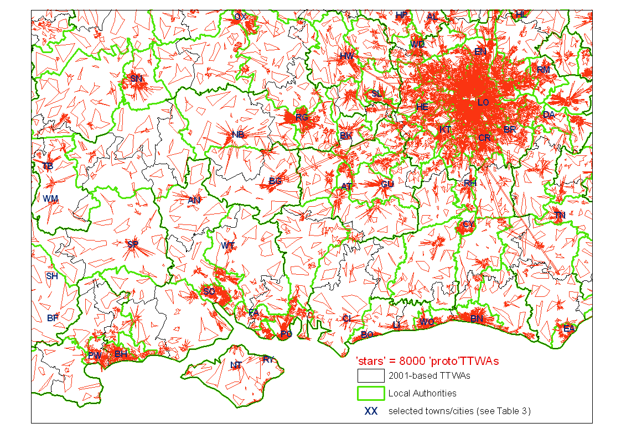

Map 2 shows that there has been an active merging process on the Isle of Wight and in fact this has resulted in every ‘proto’TTWA including at least one small town.

Map 2 Solent/London region interim results: output from 4000 ‘proto’TTWAs
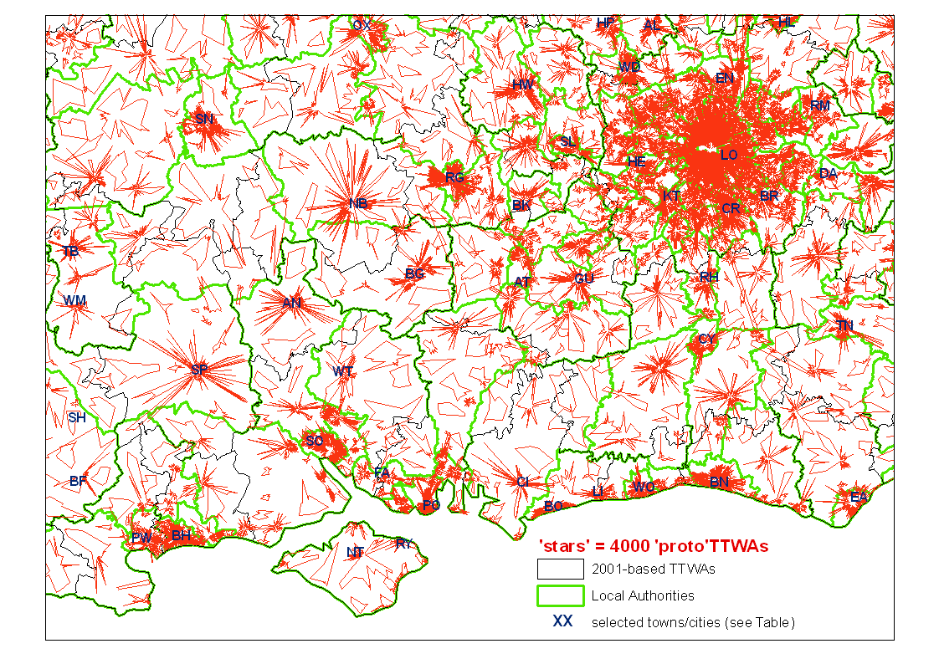
Map 3 presents the interim output after the number of ‘proto’TTWAs nationally has been halved again (to 2000). Given that ‘proto’TTWAs eliminated at this point in the process may only be around 25% self-contained in fact, it is not so remarkable that the small Isle of Wight town East Cowes still remains a separate area.

Map 3 Solent/London region interim results: output from 2000 ‘proto’TTWAs
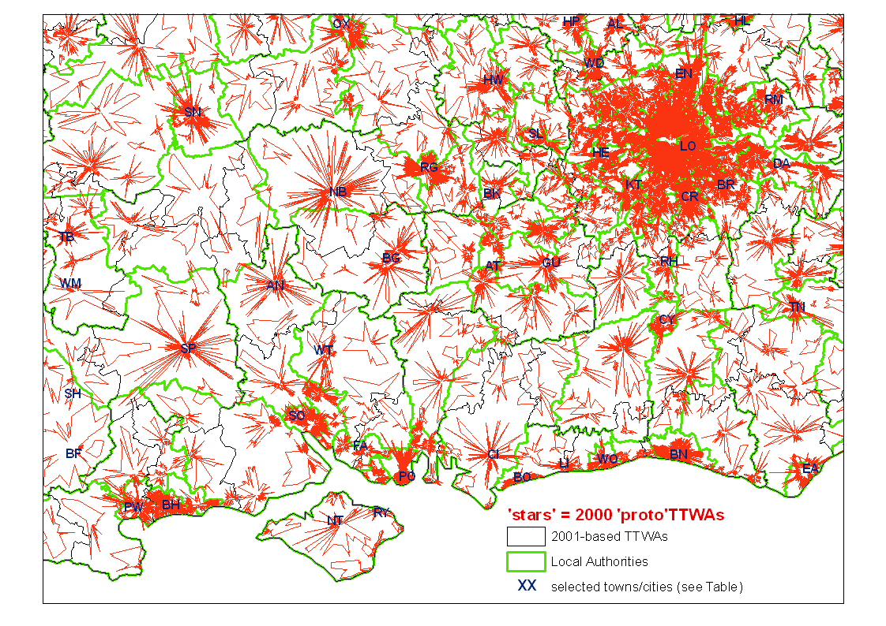
Map 4 finds that there are 7 ‘proto’TTWAs on the island when there are only 1000 nationally; this proportion is over three times higher than the Isle of Wight’s c0.2% share of the national population.

Map 4 Solent/London region interim results: output from 1000 ‘proto’TTWAs
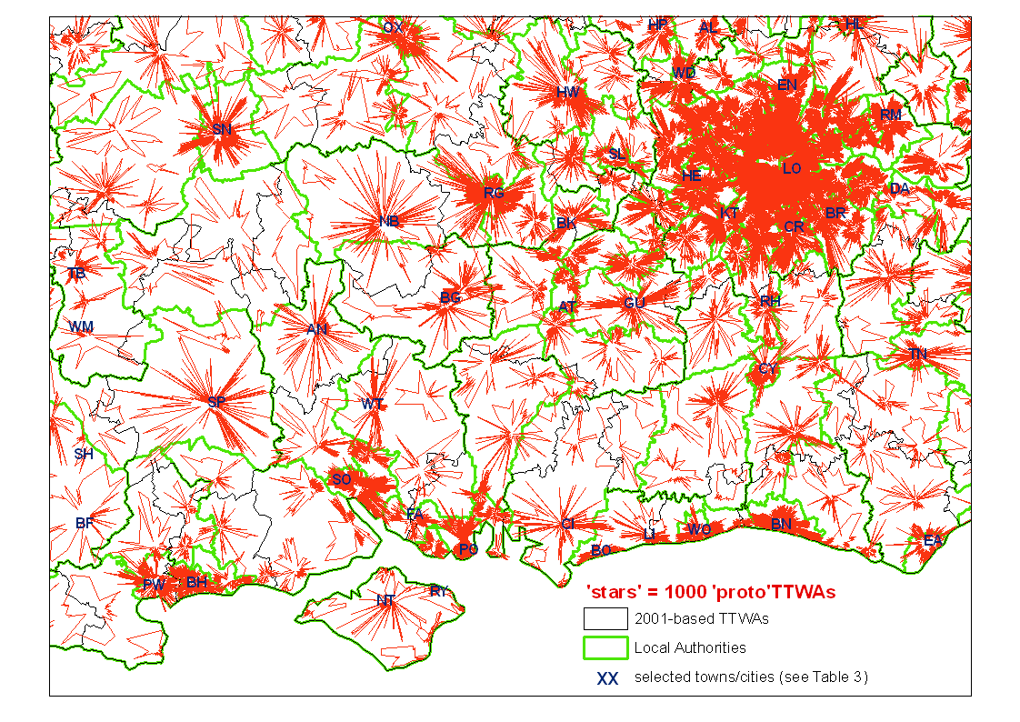
Map 5 reveals that shifting from 1000 to 500 ‘proto’TTWAs has had a dramatic effect on the Isle of Wight as just two separate areas remain, with one covering all the more urbanised parts of the island, leaving just the westerly rural area as a distinct entity.

Map 5 Solent/London region interim results: output from 500 ‘proto’TTWAs
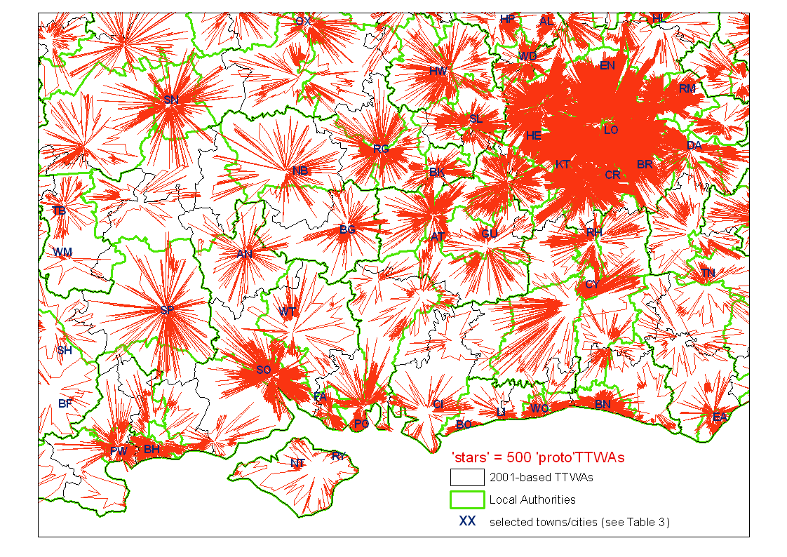
Map 6 finally shows the island as a sole ‘proto’TTWA and, in fact, it remains that way as the analysis moves on from these 250 ‘proto’TTWAs to the 224 draft TTWAs with which the computerised definition procedure concludes.

Map 6 Solent/London region interim results: output from 250 ‘proto’TTWAs
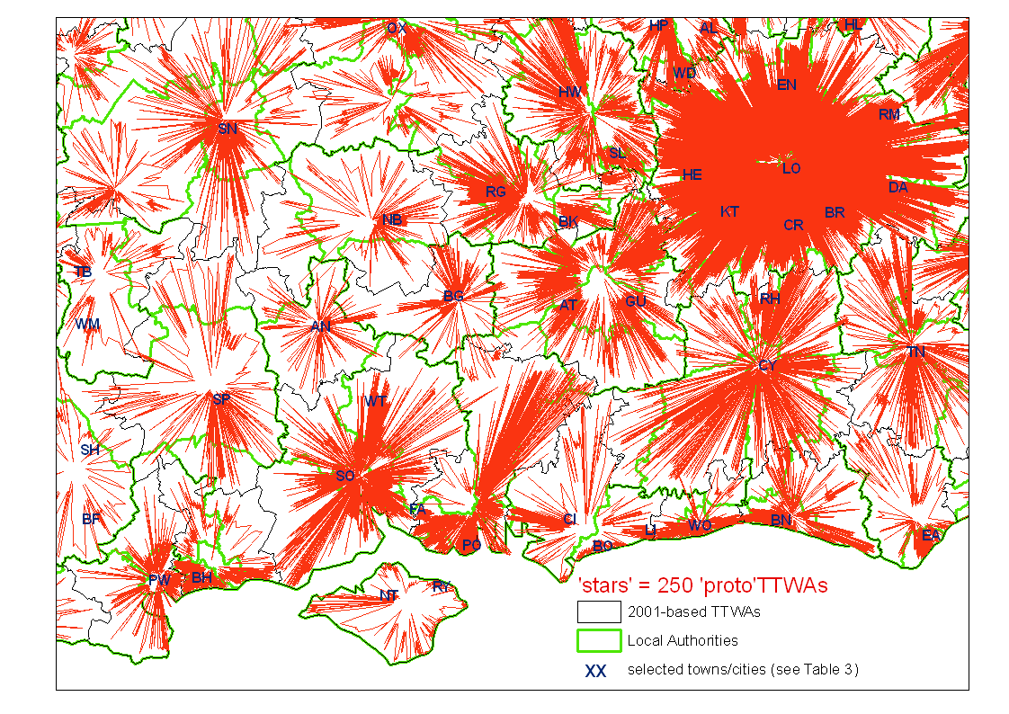
This commentary on the Isle of Wight has indicated some general features of the aggregation process. For example, an area of the country may see little or no change to its ‘proto’TTWAs over quite a lengthy span of the analysis process, only for it then to experience a rapid series of groupings and re-groupings of its constituent zones. One implication is that whatever the given setting of the ‘X’equation – that determines when the process is stopped, and so which set of TTWA boundaries is produced – some areas will have boundaries that had already been ‘settled’ over many iterations of the analysis, while other areas will be in the midst of a rather unstable phase with successive re-shuffles of the groupings of their constituent zones. Put more simply, the results output at any single point are a snap-shot from an on-going process and so the boundaries will not all have equally stable definitions at that particular point.

For the Isle of Wight case, the most dramatic analysis phase was the reduction of the national total number of ‘proto’TTWAs from 1000 to 500 because this led to a series of groupings so that the island’s set of ‘proto’TTWAs fell from 7 to 2 (Maps 4 and 5). By contrast, after the island became a single TTWA (Map 6) it would remain in that state while many other parts of the country see major changes. Thus the island has come together as a single TTWA once the self-containment requirement has reached 60% and in fact that requirement has to be raised to over 90% before there is a need for it to be grouped with part of the mainland. In this way, the Isle of Wight TTWA can be seen to be a particularly robust definition at the fairly high self-containment levels which are of most interest.

Map 6 shows the interim output from the point in the process with 250 ‘proto’TTWAs, so just 26 more ‘proto’TTWAs are deleted before the ‘X’equation requirements are met and 224 draft TTWAs are defined. Of these 26 there are 4 in the London and Solent region used for illustration here, and the different outcomes in those areas exemplify an important feature of the definition process. Map 6 shows a separate ‘proto’TTWA between Oxford and Newbury which includes Abingdon and several Thames Valley small towns. When the area is deleted – as one of 26 ‘proto’TTWAs narrowly failing to meet the self-containment minimum to be a TTWA – it is then wholly grouped into the Oxford TTWA (apart from a very minor exception of a village area east of Faringdon). The latter fragment joins the Swindon TTWA which is also the beneficiary of a much more significant gain from another of the last 26 lost ‘proto’TTWAs viz: the area around Chippenham (Map 6 shows this lying between Swindon and Trowbridge). Two substantial parts of this large ‘proto’TTWA are grouped in a different way to the majority: the Corsham area is grouped with Trowbridge while an area to the west joins Bath; the remainder joins Swindon which, once the final draft boundaries have emerged, has also gained the Cirencester and Stroud area to the north west.

These examples are being described here to demonstrate how the definition method seeks to ‘self-optimise’ each time that a ‘proto’TTWA is deleted, with the key to this process being that it does not assume that the whole of the ‘proto’TTWA will be best kept together in the subsequent re-grouping of the areas concerned. Perhaps the most vivid example of this process is provided by the Basingstoke ‘proto’TTWA which is the fourth of those in this region among the last 26 to be deleted before the draft boundaries are defined. The town itself and much of the nearby area is grouped with the Guildford area to the east, but of the more outlying parts of ‘proto’TTWA there are significant areas joining all the other five adjacent TTWAs, from Reading in the north to Newbury and Andover in the west and Southampton and Portsmouth in the south, with Portsmouth gaining the largest share (including Alton and other small towns).

There is a final implication to be drawn from the observation that different parts of the country will have more robustly defined boundaries at different points in the process. This implication follows from the key reason for the pattern that has been observed: any selected level of self-containment will pick out recognisable commuting patterns in some areas and not others. For example, a level of around 40% might find neatly localised clusters of commuting around rural towns – as found on the Isle of Wight – but also suggest a rather chaotic pattern in and around a large city, with a few larger suburban centres as separate ‘proto’TTWAs whereas other suburbs around them have merged with the main conurbation centre. One final example here concerns London which has the most complex commuting patterns of all. Map 4 shows the ‘stars’ at the point in the process with 1000 ‘proto’TTWAs (nb. in London these can have self-containment of little more than 20%). Map 4 is at a scale which makes the detail in the capital difficult to see but the boundaries of these ‘proto’TTWAs comprise a readily interpretable pattern. The conurbation centre is consolidated into a single ‘proto’TTWA covering most of inner London (roughly 15-20kms across) that is ringed by 13 ‘proto’TTWAs (Woolwich—Bromley—Croydon—Sutton—Kingston—Hounslow —Ealing—Harrow—Hendon—Barnet—Enfield—Walthamstow—Stratford). There are also 6 further out which include substantial parts of Greater London (Uxbridge in the west and Woodford—Romford—Barking—Bexley—Orpington in the east), along with others such as Epsom and Cheshunt which are beyond the official London boundary but part of the physical conurbation.

Map 6 showed interim outputs from shortly before the computerised analysis reached its final results. The final results comprise a set of ‘draft’ TTWA boundaries, but there is a further procedure to carry out before the final TTWA definitions are established. Regional and local views of the draft boundaries produced by the computerised analysis are sought, for a number of reasons:
- the computerised definition procedure is not constrained by contiguity, but the boundaries eventually published must identify a set of TTWAs which are each internally contiguous, so knowledge ‘on the ground’ is useful to ensure that the minor changes made to remove non-contiguities (so the final definitions satisfy principle 4 in Table 1) are the changes which produce the most appropriate set of TTWAs;
- the analyses also took account of neither local authority (LA) boundaries nor the limits of built-up areas, but, all other things being equal, users find TTWAs more useful if their boundaries are aligned with LA boundaries, and do not split coherent urban areas; and also
- although the computerised analysis may have produced the best overall set of results, there will be some areas where these results are sub-optimal and so it is reasonable to allow principal users to suggest alternative boundary alignments they consider to be more appropriate.

In previous TTWA definition processes there had been some cases where changes to the ‘draft’ boundaries were suggested on the grounds that some time has passed since the Census was taken and in a few areas commuting patterns could be shown to have changed greatly in the intervening period (eg. due to building a new bridge). Such a possibility was not raised in the latest definition process so the TTWAs are all genuinely 2001-based in their definitions.

Unlike in the two previous ‘rounds’ of TTWA definitions, there was no comprehensive formal consultation exercise on the ‘draft’ boundaries (ie. the results emerging from the computerised analysis). The last year had seen ONS develop a network of staff across the English regions so they, with colleagues in the devolved administrations, collated views from each part of the country. Figure 4 presents the decision matrix used to decide which of the possible changes to the draft TTWAs to accept. In effect, priority was given to changes removing any non-contiguities in the draft boundaries, and also for any changes which increased the number of separable TTWAs in total. Proposals aligning TTWAs with LA boundaries, or shifting a TTWA boundary so that an urban area was no longer severed, were also favoured to some degree. At the
same time, any proposal was rejected if it reduced the number of TTWAs or would cause a TTWA to fall below the ‘X’equation setting that ensures all TTWAs meet the size and self-containment criteria (Figure 2). If there were alternative proposals for any area, the one preferred is that classified to a cell nearer the top left-hand corner of the decision matrix (Figure 4): in this way, other considerations taken into account include the preference for making as few changes as possible, especially if the draft boundary seems robust (ie. its alignment had been repeated in the results of several alternative analyses).

Sensitivity analyses

It is important to assess the sensitivity of the TTWA definitions to changes in the way they are analysed. In other words, the research aims to answer three questions:
- how much difference does any change make to the definitions, and specifically
- which areas are more affected by the change, and following on from that
- can one set of results be shown to be preferable to the other?
The simplification of the TTWA definition procedure, to rely on a single step process, is a key example of change between the 1991-based and 2001-based definitions; hence the two questions need to be answered by carrying out an unsimplified version of the analysis and examining its results. This sensitivity analysis is reported below, along with an analysis of the results of changing the ‘X’equation settings back to the levels that were used when defining 1991-based TTWAs.

The other sensitivity tests required relate to changes which were described in the last section of this report; that is, changes which were introduced as a result of the new
Figure 4 Decision matrix for assessing a proposed change to the draft set of TTWAs
opportunities created by innovations in the 2001 Census commuting data. The major change was the shift away from the use of wards to zones with their far greater level of detail. Separate but related sensitivity tests are called for here:
  - the first test takes the analysis that produces the draft 2001-based TTWAs and applies it to data for wards which, like the zone dataset used for the
2001-based TTWAs, had not been through the SCAM process;
- the second such test uses the published ward dataset (ie. one which has been through the SCAM process).
The two separate tests are carried out so the ‘ward effects’ and ‘SCAM effects’ can be separately identified.

The one other sensitivity test relates to the removal, from the definition procedure for 2001-based TTWAs, of the refusal to allow any TTWA to span the borders between England and either Wales or Scotland (a refusal that had been in place for decades, although initially with a small deviation to allow the western suburbs of Chester which are in Wales to be in the same TTWA as the rest of the city). Given that this change is not expected to affect areas at some distance from these borders, this test would be expected to be the one likely to find the least significant impact overall. Along with sensitivity testing variations in method of definition, it is appropriate to use the same ways of comparing alternative sets of boundaries to show the change made to the draft boundaries by the decisions taken on changes proposed in the consultation (Figure 4). At the same time, it will be of wide interest to examine the difference between the 2001-based results and the 1991-based TTWAs.

Where two sets of boundaries are significantly different, the next question is whether the alternative to the default set of boundaries is more desirable. This question can only be answered after identifying what is looked for in TTWA definitions: what would make one set of boundaries observably superior to another. In practice, some of the key considerations have already been identified in this report.
- Maximising the number of separate TTWAs was an objective at the outset.
- Users often state a preference for a London TTWA which is not very large.
- There are currently-separate TTWAs whose merging would be particularly likely to concern users, usually because they are adjacent1991-based TTWAs with sharply contrasting unemployment rates:a selection of these was identified, and the results produced in these areas by various different forms of analysis were then monitored.
Table 4 reports the results on the first two criteria just identified for the alternative sets of TTWA definitions described above. On both criteria the best values are seen to be for the 98TTWAs but, of course, retaining those boundaries is not an option because many are not self-contained enough in terms of 2001 commuting patterns.
None of the other alternative boundary sets comes even close to matching the published 2001-based TTWAs on the principal criterion of the number of separable TTWAs with the required statistical properties. The size of the London TTWA is less critical in practice, but nonetheless it is interesting that the two ward-based analyses yield a smaller London than any of the zone-based analyses here. This minor benefit of the ward-based results is by far out-weighed by the extra precision possible when constructing TTWA boundaries from zones which are four times more numerous. On balance, Table 4 delivers a rather unexpected message: there is not a great deal to choose between most of the sets of boundaries in relation to the critical objective of maximising the number of separable TTWAs meeting the statistical requirements on the 2001 commuting data.

Table 4 Basic results from alternative forms of TTWA definition method
short-hand name | How it differs from the draft boundaries produced by the computerised analysis | no. TTWAs | London working residents [no.]
98TTWAs | These are the 1991-based TTWAs | 308 | 2890820
PUBLISHED | These are the final 2001-based TTWAs | 243 | 3817513
*basic* | these *are* the draft boundaries | 224 | 3812097
changes to the *basic* method making it more like the 1998TTWAs
<borders | national borders imposed | 224 | 3812097
<old'X'equation | 69.5% & 20,000 in X-equation | 197 | 3882164
<unsimplified | full unsimplified 98TTWA method | 221 | 3290511
<wards | Definitions based on ward data (no SCAM) | 223 | 3877923
change to the *basic* method making it less like the 1998 TTWAs
>SCAMwards | Definitions based on ward data (with SCAM) | 220 | 3307782

Table 5 explores evidence related to specific differences between sets of boundaries. Each row relates to the pair of neighbouring areas, as identified on the left of the row. In each cell there is a “U” if that row’s pair of areas has been grouped together by the set of boundaries identified at the top of that column. For example, the cell in the bottom right-hand corner contains a “U” which indicates that the two mid-Ulster towns Magherafelt and Cookstown were grouped into a single TTWA by the analysis using ward data to which SCAM had been applied. This set of area pairs is presented with some rows ‘boxed’ together: in these cases it can be seen that one or more of the areas appears in at least two rows pairs. For example, Cookstown could be grouped with Magherafelt or with Dungannon (it is also possible that the three areas all remain separate from each other). The first column reports the way these area pairs were dealt with by the 98TTWAs and it can be seen that in each ‘box’ there is at least one of the area pairs that was not grouped together (as shown by a “-” rather than a “U”). In general, it could be said that the preferred set of 2001-based boundaries is the one with fewest instances of “U” in its column, but this comes close to simply repeating the stated preference for as many separable TTWAs as possible.

Table 5 has another feature, and this is one which helps to distinguish the analyses which are more distinctive in their boundaries. The column headed *basic* is the set of draft TTWA boundaries that emerged from the computerised analysis and were input to the consultation process that led to the final 2001-based TTWA definitions: these are the ‘bench-mark’ set of 2001-based boundaries to compare others against. All the cells in this column are coloured yellow, and cells in other columns are then coloured yellow too if they have the same value (whether it is “U” or “-”) as the value in the *basic* column for that pair of places. This means that the extent to which any
Table 5 Differences between the results in selected areas from alternative forms of TTWA definition method
"U" = pair in same TTWA "-" = pair split | sets of results | 98TTWAs | PUBLISHED | *basic* | <borders | <old'X'equation | <unsimplified | <wards | >SCAMwards
[yellow] = same as *basic*
Place pairs …
Bradford | Leeds | - | - | - | - | - | - | - | -
Bournemouth | Poole | - | - | - | - | - | - | - | -
Loughborough | Leicester | - | U | U | U | U | U | U | U
Melton Mowbray | Leicester | - | U | U | U | U | U | - | U
Edinburgh | Livingston | U | - | - | - | U | - | - | -
Falkirk | Livingston | - | - | - | - | U | - | - | -
Shrewsbury | Whitchurch | U | - | - | U | - | - | U | U
Wrexham | Whitchurch | - | U | U | - | - | U | - | -
Telford | Whitchurch | - | - | - | - | U | - | - | -
Sunderland | Durham | U | - | - | - | - | - | - | -
Newcastle | Durham | - | U | U | U | U | - | U | U
Bishop Auckland | Durham | - | - | - | - | - | U | - | -
Bishop Auckland | Darlington | - | - | - | - | U | - | U | U
Manchester | Oldham | U | - | U | U | U | U | U | U
Manchester | Rochdale | - | - | U | U | U | U | U | U
Oldham | Rochdale | - | U | U | U | U | U | U | U
Chatham | Gravesend | U | - | - | - | - | - | - | -
London | Gravesend | - | U | U | U | U | U | U | U
Dungannon | Cookstown | - | - | - | - | U | - | - | -
Magherafelt | Cookstown | U | U | U | U | U | U | U | U

set of boundaries differs from the bench-mark *basic* boundaries is indicated by the number of its cells which are not coloured yellow.

Looking at the 98TTWAs column finds that over half its cells are not yellow. In many cases this is because the 1991 data found the pair of places – like Leicester and Loughborough – were both sufficiently self-contained to be separable, whilst on the 2001 data their commuting patterns are too integrated for them to remain separable (even though the self-containment minimum has been lowered). The one case of the opposite change is Edinburgh and Livingston: it seems the latter’s New Town growth has reinforced its relative independence from Edinburgh’s thriving labour market. With the pairs of places selected here there are few substantive differences between the final PUBLISHED 2001-based TTWAs and the *basic* results produced by the computerised analysis. Table 5 draws attention to the influence of the consultation stage on the boundaries around Manchester because it shows that both Oldham and Rochdale had been grouped with Manchester in the *basic* boundaries, but after the consultation the two towns were split from the core city TTWA and found to pass the self-containment minimum when grouped as a single TTWA combining them both.

Table 5 shows in its right-hand columns the extent to which various changes to the definition method alter the analysis results. An indication of the degree of sensitivity to each change to the method can be gained from a simple count of non-yellow cells in each column (although the result is of course influenced by the ‘unscientific’ choice of these pairs of places). On this basis, the results are least sensitive to a change back to (a) constraining the TTWAs to fit within national borders or (b) using the old unsimplified method of analysis. Table 4 had shown that in fact the latter has a larger effect on the results overall, and there is some evidence to the same effect here with the places affected by the latter change (such as Newcastle and Durham) being a lot larger than those affected by the national border (eg. Wrexham and Whitchurch).
Tables 4 and 5 agree that reverting to the old ‘X’equation is the change to which the results are most sensitive. Table 5 shows that one example of this sensitivity is that
Livingston – the one ‘new’ 2001-based TTWA split out from a 1991-based TTWA – would remain part of the Edinburgh TTWA if the old ‘X’equation values are retained.

Table 5 suggests a surprising result: it appears that using ward data that was subject to SCAM produces boundaries more similar to the *basic* results than does using ward data which – like the zone data used for the *basic* analyses – has not been through the SCAM adjustment process. This would mean that if the SCAM effect was ‘additional’ to the effect of shifting to using wards, then the SCAM effect redresses some of the change brought about by the shift to wards! Table 4 in fact corrects this assessment by showing that on the critical task of maximising the number of TTWAs the zone-based *basic* is more similar to the results from the ward-based data that had not been subject to SCAM than to those from the dataset that had.

It is not easy to come to a summary assessment of which set of boundaries is the ‘better’ in terms of a preferable set of groupings: for example, what could be the basis for a strong assertion that the better set of TTWA boundaries is whichever set has grouped Whitchurch with Wrexham rather than Shrewsbury or Telford? Table 5 has then been mainly of value in giving a small window onto what the sensitivity of the boundaries means to a small selection of places. To justify the choice of the results termed *basic* here it is necessary to go back to the core objectives that were set for the research, such as the key aim to maximise the number of separable TTWAs. Table 4 has shown that the *basic* set was the one which best met this objective (bearing in mind that the 98TTWAs cannot be considered because they do not meet the ‘X’equation requirements (with 2001 data), and that the PUBLISHED results were not entirely produced by computerised analysis and so are not strictly comparable with the other boundary sets considered here).

The other sets of results with an equal – or nearly equal – number of separable areas are all less preferable from the scientific stand-point that, all other things being equal, values both simplicity and precision. Analysing zone data is preferable to analysing wards on the grounds of precision, due to the extra level of detail provided, and the fact that the SCAM effect is intentionally introducing additional imprecision clearly leads to the preference to not use the ward dataset which had SCAM applied to it. The imposition of the national borders on the boundaries can be seen as contrary both to the aim of precision – because it is preventing the method finding the optimal solution wherever it is – and also the aim of simplicity, because it is an unnecessary extra requirement in the method. Finally the simplicity argument most obviously favours the new ‘streamlined’ method which produced the *basic* results in contrast to its predecessor, the unsimplified method which was used to define TTWAs in the two previous decades.

Results

In this part of the report the set of 2001-based TTWAs are examined in two ways. First there is a brief presentation of their main statistical properties; this leads onto some observations about variations within the set of TTWAs so that, for example, there is evidence on whether or not TTWAs with larger employed populations also tend to have larger physical areas. The one other way in which the new areas are examined is cartographically, with a short description accompanying each map.

Table 6 presents the rank correlations between six statistical characteristics of the 2001-based TTWAs:
- resident workforce size (ie. number of residents in work)
- lower self-containment (ie. the lower value on the following two attributes)
- supply-side self-containment (% employed residents who work locally)
- demand-side self-containment (% local jobs taken by local residents)
- physical area size (viz: number of square kilometres within the boundary)
- job ratio (ie. number of local jobs, divided by number of employed residents).
Table 6 shows in its top left data cell that the two statistical values which are combined in the X-equation (viz: resident workforce size, and the lower of the two self-containment rates) are virtually independent of each other. This suggests that combining the two measures in the X-equation involves very little duplication: the two measures find very different TTWAs at the upper or lower end of their value ranges.

Table 6 Correlation between statistical attributes of 2001-based TTWAs
rank correlation coefficient | number of employed residents | supply-  side self-containment | demand-side self-containment | physical area (sq.km) | job ratio
lower self-containment | -0.045 | 0.980 | 0.791 | 0.496 | 0.475
job ratio | 0.296 | 0.569 | -0.093 | 0.275
physical area (sq.km) | 0.044 | 0.507 | 0.406
demand-side self-containment | -0.215 | 0.730
supply-  side self-containment | 0.005

It was mentioned earlier in this report that there are many more TTWAs where the supply-side self-containment value is lower than the demand-side value, rather than the other way round. Table 6 confirms this, because lower self-containment values are more strongly correlated with supply-side values (0.980) than they are with the demand-side values (0.791). That said, both these correlation values are rather high, and the correlation between demand- and supply-side values (0.730) is also high: this indicates that there are few TTWAs with one high self-containment value and one very much lower. Figure 5 gives the evidence for this interpretation by showing all the TTWAs’ self-containment values. Most cases are distributed close to the diagonal where TTWAs with identical demand- and supply-side values are located. Figure 5 also draws attention to the side of the diagonal on which each TTWA lies, because those which lie below the diagonal are coloured red to indicate that they have positive job ratios (ie. more jobs at local workplaces than there are employed residents living locally). Table 6 reveals that TTWAs with high job ratios are more likely than others to have high supply-side self-containment rates (correlation 0.569), whereas there is no real relationship with demand-side self-containment (-0.093). TTWAs with high job ratios are employment centres and as a result:
- their residents have enough local jobs so they tend not to need to travel far for work (leading to high supply-side self-containment rates), but also
- their high job ratios suggest that local jobs are not all staffed by local residents and so their demand-side self-containment rates are not high.

Figure 5 2001-based TTWAs: self-containment rates and job ratios

Map 7 depicts the job ratio values, finding the pattern that would be expected, in that low job ratios are found in TTWAs near high job ratio areas like conurbation centres. This produces a distinctly ‘patchwork’ appearance with high and low values adjacent to each other. If larger TTWAs were defined then these localised contrasts would largely disappear because the larger grouping would tend to minimise the likelihood of people commuting across its boundaries, thus ‘cancelling out’ both high and low job ratio values and yielding a value close to 1.0 for the new large area. This pattern is not limited to the major cities. Map 7 shows that in the northern mainland extremity of Caithness in Scotland there are two TTWAs with very different values, due to the locally substantial and largely one-way commuting flow from the Wick TTWA to the Thurso TTWA (which includes the Dounreay site with many of the sub-region’s jobs).

Map 7 2001-based TTWAs: job ratios
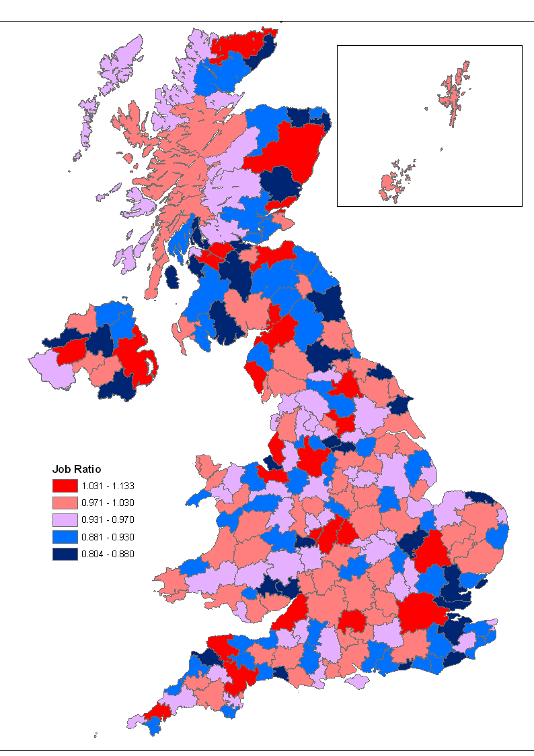

Table 6 also shows the correlations between the statistical characteristics discussed so far and TTWAs’ physical area size. Physically larger areas are more likely to have positive job ratios (with the two variables correlated at 0.275), but not to have larger workforces (0.044). As just suggested, TTWAs with larger areas tend to have higher self-containment rates (Table 6 shows that TTWAs’ lower self-containment rates and their physical sizes are correlated at 0.496). This will be due to commuting flows of a ‘typical’ distance being less likely to cross more widely spaced boundaries.

Map 8 2001-based TTWAs: lower of the self-containment rates
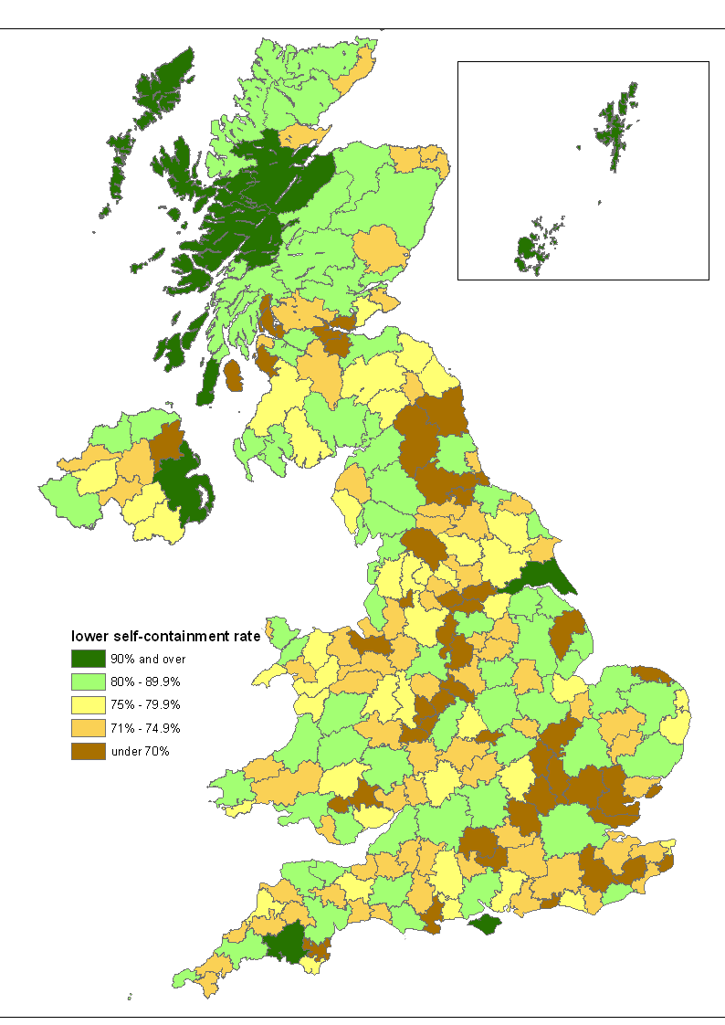

Map 8 shows the lower self-containment rate for each of the 2001-based TTWAs. The highest values are only found in relatively isolated coastal TTWAs: these areas necessarily have fewer neighbours which is one reason for them having a lower level of flows across their boundaries. The lowest rates tend to be clustered around the largest urban centres, ranging from London and provincial conurbations like Birmingham to some smaller centres like Colchester (which has Clacton as its neighbouring TTWA with very low self-containment). As was shown earlier with the step-by-step mapping of the emergence of TTWAs in the London and Solent region, the areas which are in existence at any particular level of self-containment are simply one set out of a sequence of boundary realignments, and so it is unsurprising that the 2001-based TTWAs with the lowest self-containment rates includes several different types of place, and also some areas in each region of the country.

Maps 9 to 18 cover the country in enough detail to show, for example, how far the 2001-based TTWAs are aligned with local authority areas (LAs). Map 9 shows that the Swansea Bay TTWA covers two complete LAs (Swansea and Neath Port Talbot) along with a ‘fringe’ of wards from the LAs to the north (including the Llanelli area). To the east are two TTWAs (Merthyr Tydfil & Aberdare and Ebbw Vale & Abertillery)

Map 9 2001-based TTWAs: south-western England and southern Wales
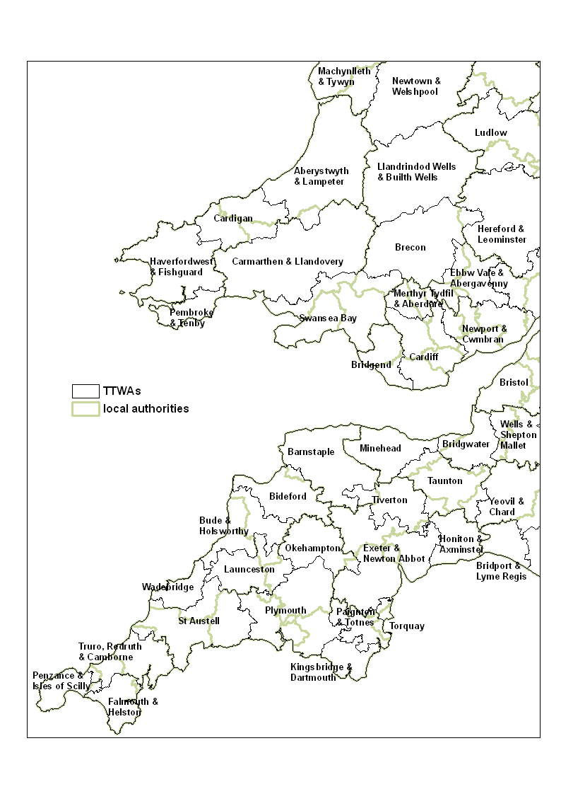
which show that the Heads of Valleys remain relatively self-contained in commuting terms from the increasingly dominant Newport and Cardiff on the coast. In the south west of England numerous small country towns like Tiverton and Launceston persist as distinct TTWAs, while Torquay provides the most remarkable case of a physically small area meeting the self-containment criteria to be a separate TTWA (even though it is part of a continuously built-up Torbay area, along with Paignton which forms the main urban area of the separate Paignton & Totnes TTWA).

Map 10 has a similar case to the Torquay-Paignton division with the definition of two separate TTWAs for Bournemouth and Poole despite them being one continuously

Map 10 2001-based TTWAs: central southern England and the Midlands
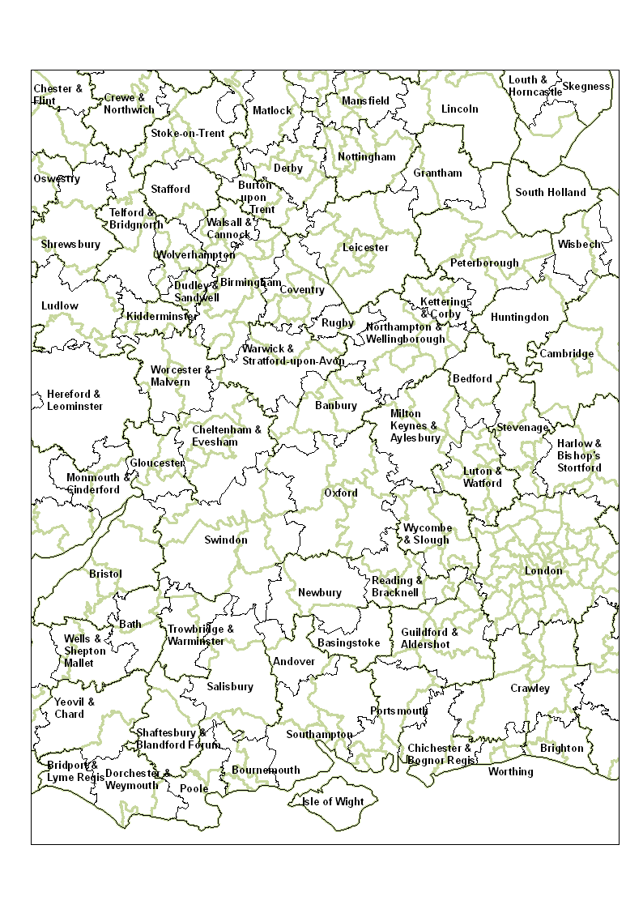
built-up urban area. It is not entirely a coincidence that both these cases cover
seaside resorts, because there is a consistent tendency for such towns to have smaller labour markets than would be expected given other factors such as their population size: one reason will be that resort employment is dominated by low paid work and few people in such jobs commute very far. Map 10 includes numerous pairs of potential ‘twin cities’ such as Southampton and Portsmouth on the south coast, Gloucester and Cheltenham in the west, Birmingham and Coventry (West Midlands), or Derby and Nottingham (East Midlands). Each of the towns and cities has emerged as the main urban area of a separate TTWA: this means data users can compare labour market trends in each of the potential ‘twin cities’ separately, perhaps then monitoring the evidence of them becoming more integrated in the future (in the way that affects most pairs of neighbouring places). One perhaps surprising finding was that the 1991-based TTWA for the area around Stroud is not self-contained enough to be a separate 2001-based TTWA: this has led to Stroud grouping not with nearby Gloucester but instead with the more distant Swindon over the Cotswold watershed, a linkage presumably caused by the strong growth of the Swindon local economy.

Maps 10 and 11 show London and its surroundings. One noteworthy feature of the London TTWA is that it is the only TTWA larger than the region to which it belongs (although this is less a consequence of the London TTWA being large than of this region being far smaller than any other). The surrounding TTWAs generally look intuitively reasonable, with Stevenage as the most extreme example of an area shaped by transport routes (in this case, the radial routes in and out of the capital). Map 11 also shows more rural East Anglia and these areas have seen some of the strongest change in the shift from the 1991-based to the 2001-based TTWAs. A large part of the explanation is that the 1991-based definitions included in these areas very many TTWAs with low self-containment rates: Figure 3 in Coombes et al (2005) showed that Eastern England was the region with the highest proportion of low and very low self-containment rates among its 1991-based TTWAs. These areas were thus very ‘vulnerable’ to the generalised trend for declining self-containment levels (due to the increasing number of longer-distance commuters). Another key factor here is that these areas saw strong economic growth and this tends to cause more rapidly falling rates of self-containment with the new affluence liable to fuel more long-distance commuting flows.

Map 12 is of particular interest because it shows effects of the decision to remove the constraint that TTWAs must fit within national boundaries. In the more southern parts of Wales (Map 9) the 2001-based TTWA boundaries have to a considerable extent followed the national border even without the artificial constraint on them to do so, but in north Wales this is far from true because four TTWAs extending north from Shrewsbury to Chester & Flint all straddle the border. The impact of this change can also spread to adjacent areas. Removing the bar on Chester linking with the nearby Welsh areas with which it has long been closely integrated means that it no longer gets linked with the Wirral area of Merseyside (simply in order to raise it above the self-containment level required of TTWAs), and this produces a much more useful set of TTWAs for users because Wirral and Chester have strongly contrasting local
Map 11 2001-based TTWAs: south-eastern and eastern England
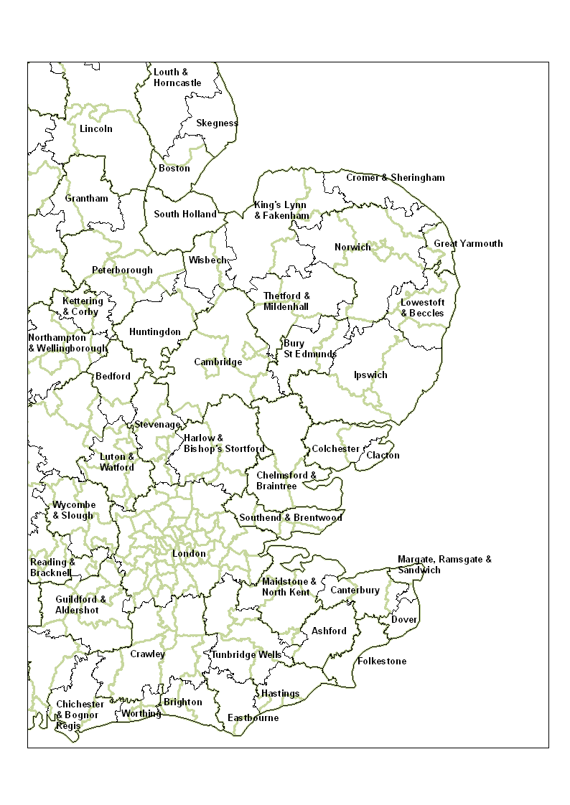
economic structures and trends. The process of grouping areas until they reach the self-containment level required of TTWAs (illustrated earlier within the London and Solent region), is particularly dynamic in areas like mid-Lancashire between Manchester and Liverpool where the closely spaced towns once had distinct local economies (eg. glass in St. Helens or chemicals in Widnes). Loss of jobs in heavy industry eroded this distinctiveness, with the motorway network make commuting between nearby towns relatively easy. What has emerged is a polycentric region whose subdivision into TTWAs produces very different boundaries depending on the level of self-containment that is required: Map 12 shows the result of the current objective, which is to define as many coherent separable TTWAs as possible with the given self-containment minima and, of course, the 2001 pattern of commuting flows.
Map 12 2001-based TTWAs: northern Wales and north-western England
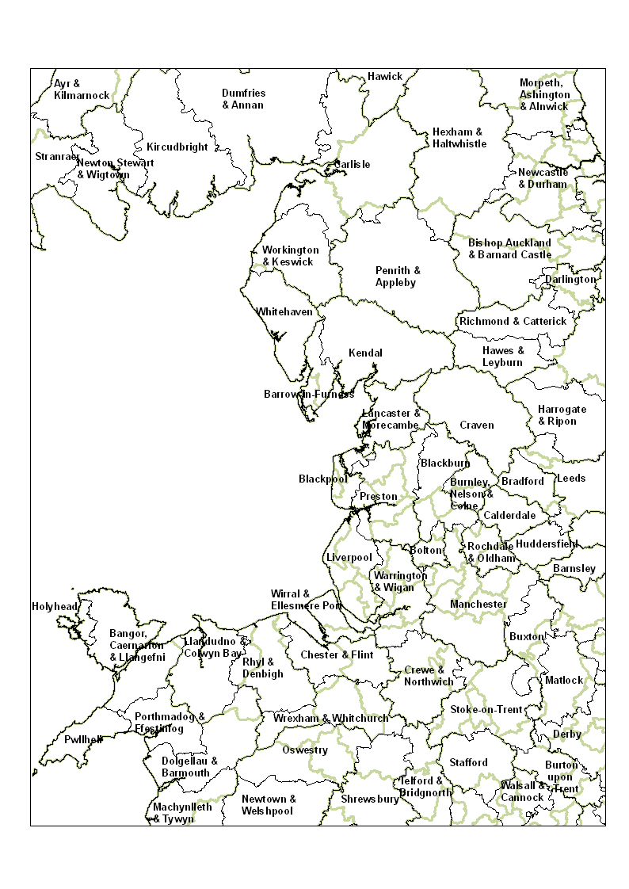
Maps 12 and 13 include some of the more upland areas of the country and the influence of topography on TTWA boundaries becomes more pronounced. A less obvious aspect of this is in upland areas TTWA boundaries are more likely to align with LA boundaries (unless the LA boundaries ignore the topography, of course). The most dramatic case is the regional boundary separating the North West and Yorkshire & The Humber: this lengthy boundary follows the Pennine watershed and all the eight TTWAs which make up the western ‘fringe’ of Yorkshire align exactly with the regional boundary. Of these eight, the two northernmost share the boundary with TTWAs in Cumbria and within the Lake District itself the topography has shaped both LA and TTWA boundaries so that they align with each other to a great extent. By contrast, some stretches of the Scotland-England border are not matched by the
Map 13 2001-based TTWAs: central northern and north-eastern England
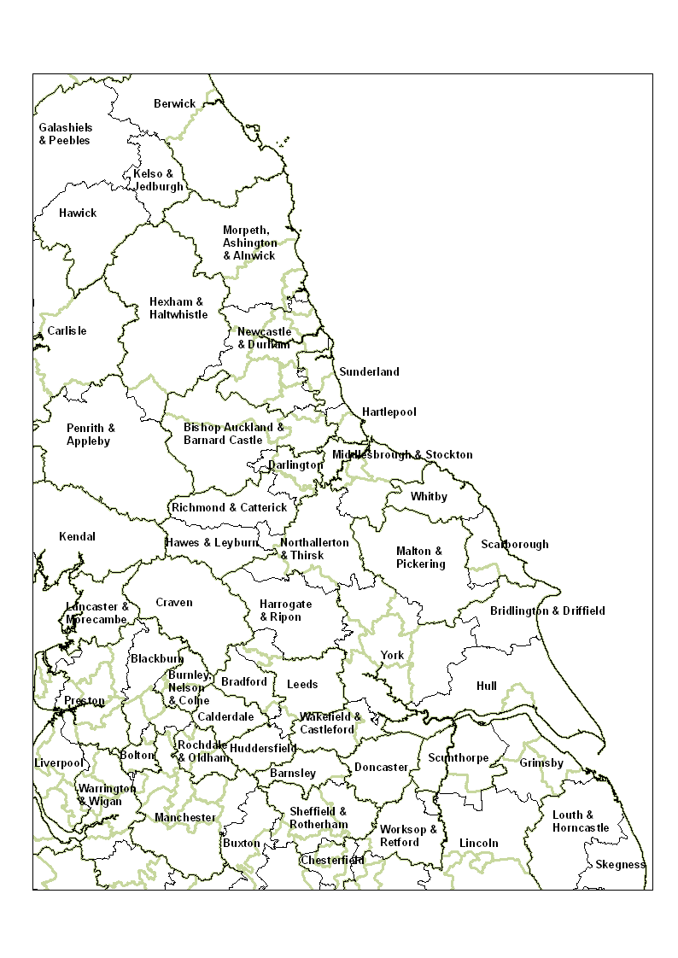
2001-based TTWA boundaries, because of the removal of the constraint preventing cross-border TTWAs: the most substantial case is the Berwick TTWA which has been extended by including the Berwickshire area in Scotland for which it has been an employment centre for long periods, due to the ease of travel across the border (Map 13).

Map 14 centres on Northern Ireland where – unlike the rest of the UK – the number of TTWAs remains unchanged in the shift from the 1991- to the 2001-based TTWAs. There is also considerable stability in the boundaries themselves, with the principal shift involving Banbridge becoming part of the Newry TTWA (rather than that which includes the Craigavon area based around Lurgan and Portadown). Among those
Map 14 2001-based TTWAs: Northern Ireland
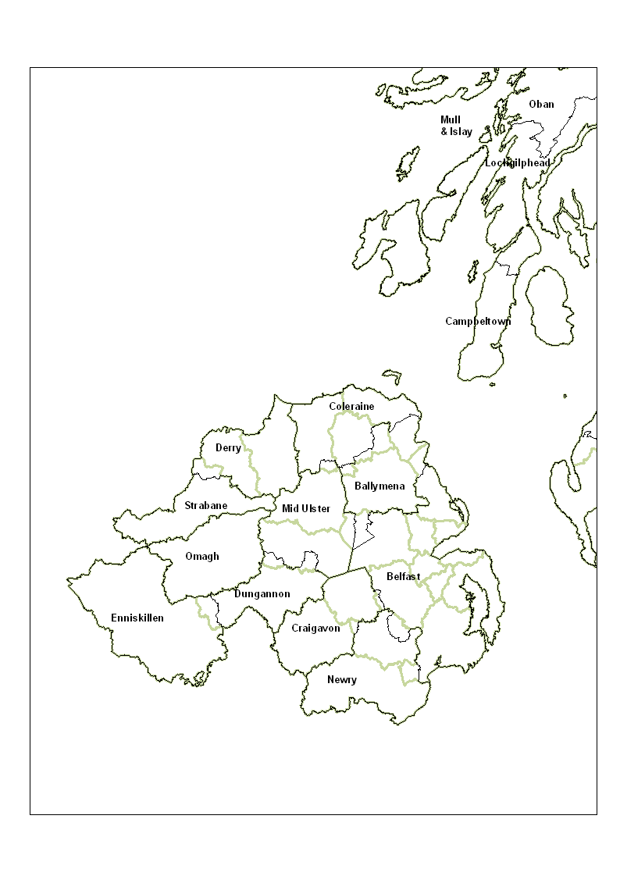
2001-based TTWAs nearest to failing the required self-containment level is the one embracing Strabane: one implication is that when the 2011 Census commuting dataset is available to be analysed, it is unlikely that Northern Ireland will still have the same number of separable TTWAs if the self-containment minimum for TTWAs remains unchanged. This prediction is based on the persistent trend for areas to see their self-containment levels fall, but in areas such as Strabane there is a very major note of reservation which needs to be made in relation to data on commuting flows. Census datasets are limited to individual states, and so the data analysed here lacks any information on workplace locations in the Republic of Ireland of commuters from Northern Ireland (nb. there is also no data on the home location in the Republic of the commuters who commute across the border in the other direction). Strabane is one of the areas most affected by this problem, because the town of Lifford is just across the border, and the border has been readily crossed here for some years.

It has been emphasised in this report, level of self-containment is the most influential factor for almost all areas in determining whether they can be separate TTWAs. Islands are the one type of area where size is much the more influential factor. Peripherality causes most islands to be highly self-contained but, at the same time, they often have small populations. With little commuting between islands, the way they are grouped together to create TTWAs meeting the minimum size requirement involves more judgement than applies in other parts of the country. Map 15 provides

Map 15 2001-based TTWAs: western and south-western Scotland
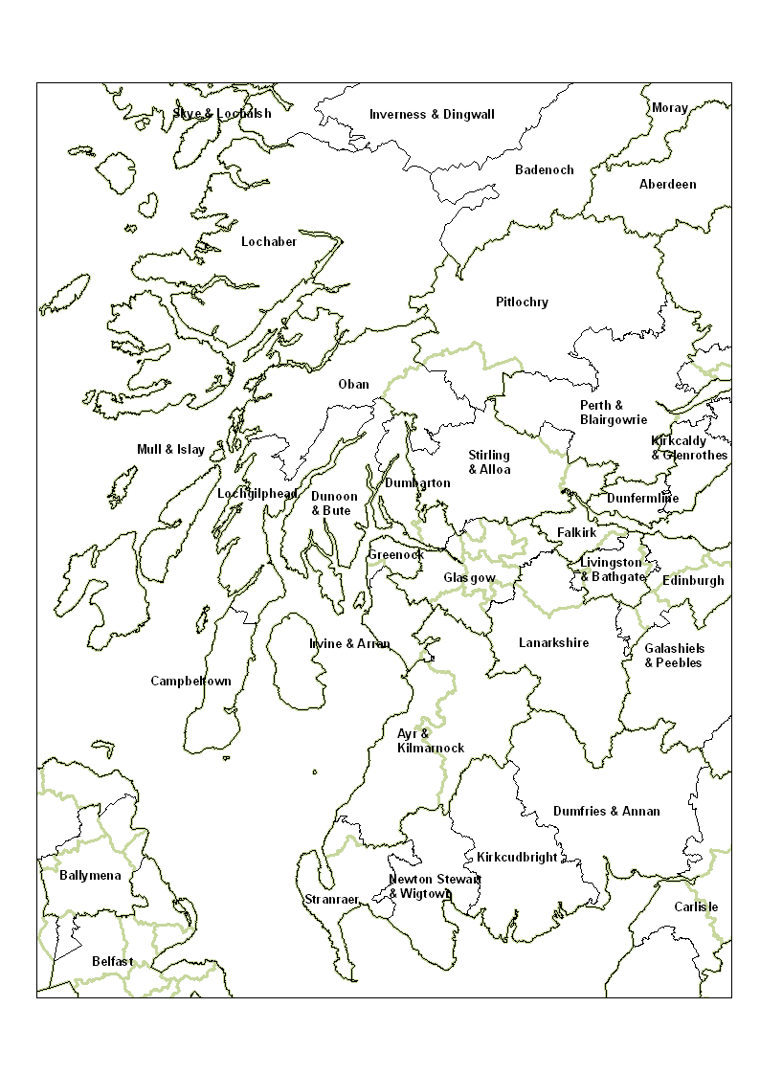
a stark example in the Mull & Islay TTWA which groups together Argyll islands whose initial allocation by the computerised analysis was rather different. The consultation with the Scottish Executive changed the way these islands and nearby mainland areas are grouped: their very high self-containment levels meant that their grouping could be determined mainly by selecting the configuration seen as of most value to users, so long as each grouping met the population size requirement. Another aspect of the consultation process was ‘tidying up’ the small minority of data zones which had been non-contiguously allocated by the data analysis. The draft Glasgow TTWA boundary included rather more than most of these imperfections (Maps 15 and 16 show that the ‘big picture’ for Glasgow was an intuitively convincing local labour market area).
Map 16 2001-based TTWAs: eastern Scotland
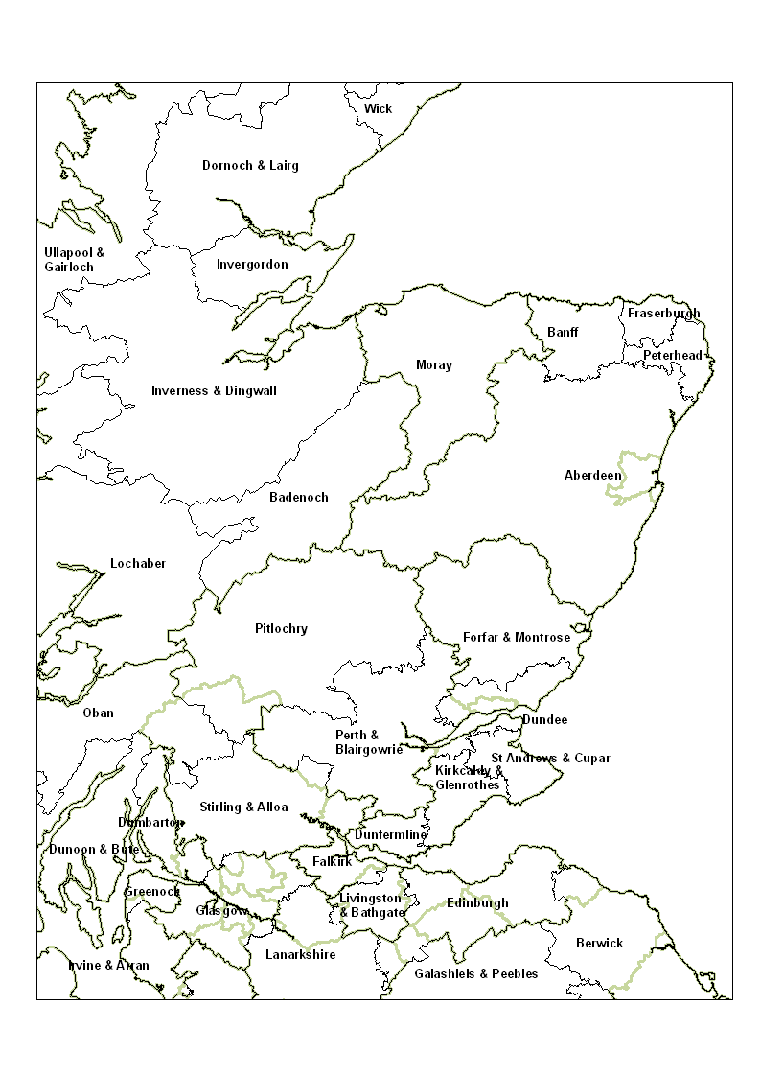
The main reason for more non-contiguities appearing in the Scottish boundaries is that the Scottish equivalent of LSOAs (termed Data Zones) are significantly smaller and so are more liable to include areas where a small number of unusual flows determine the allocation of the area.

Map 16 includes the one case in the UK of a 1991-based TTWA being superseded by two 2001-based TTWAs: in effect, the 1991-based Edinburgh TTWA has been divided between the Edinburgh and Livingston & Bathgate 2001-based TTWAs. Maps 15 to 17 show that Scotland has many examples of upland areas and some other topographic features shaping the TTWA boundaries with, once again, the result

Map 17 2001-based TTWAs: the Hebrides and north-western Scotland
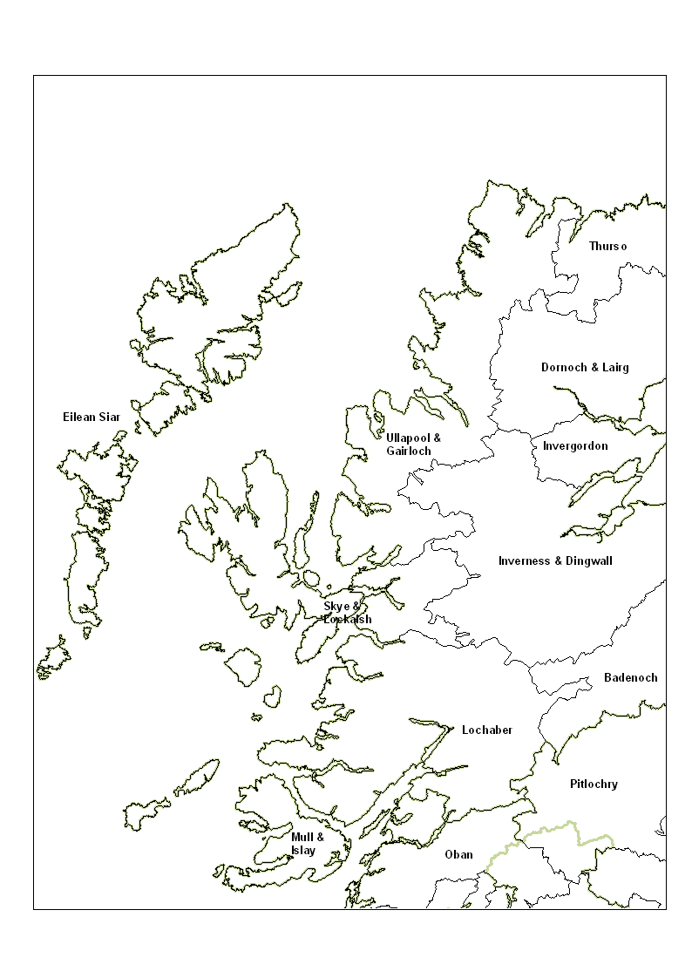
that the TTWAs boundaries align with LA boundaries quite often. Aberdeen and the rest of north-east Scotland provides one of the counter-examples to an otherwise very widespread pattern in which the TTWAs in any one part of the country are much the same in physical size. The very distinctive local economy of Aberdeen is supporting many longer-distance commuters, leading to its very wide TTWA boundary, and this stands in very sharp contrast to the localised commuting flows in and around the neighbouring small coastal towns to the north.

Maps 17 and 18 cover the western and northern isles as well as much of the Highland region on the mainland. Map 17 includes one notable change from the

Map 18 2001-based TTWAs: Shetland and Orkney Islands
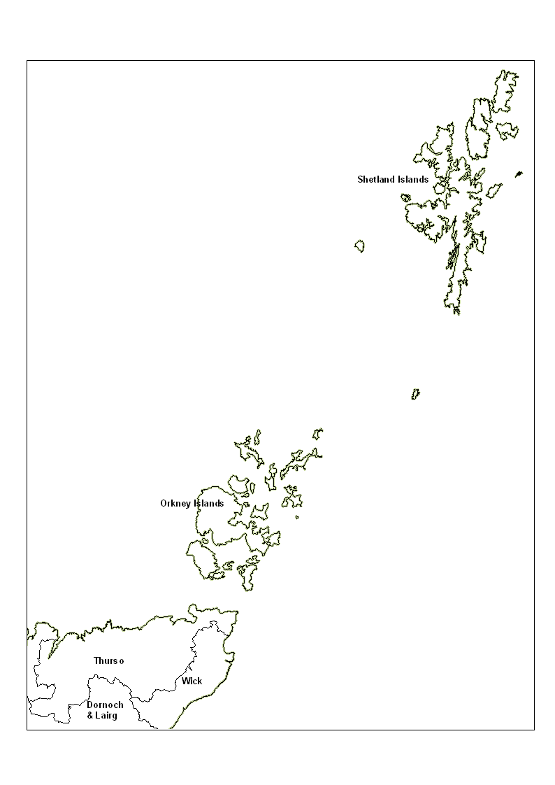
1991-based TTWAs: unlike earlier sets of TTWAs, the 1991-based boundaries had included two separate TTWAs – Lewis & Harris and Uists & Barra – in the western isles but, in the 2001-based results, these are re-united (as the TTWA of Eilean Siar). The reason was not the reduction in self-containment which caused almost all the other reductions in separable TTWAs; instead the 2001 data showed the population of Uists & Barra to have fallen below the level required for TTWAs. On the mainland, the Highland LA provides the most dramatic example of one way in which TTWAs are invaluable to data users. This one LA covers the territory divided into nine distinct TTWAs so the data reported by TTWA can show very considerable intra-LA variation; this is especially true for local economic analyses, because there are hugely differing local economies here, from the resource-based activities in Lochaber and tourism focus of Badenoch to the growing services in Inverness and Thurso’s unique nuclear industry presence.

Evaluation

The core objectives set for the research reported were to review the method used for defining TTWAs and to analyse the 2001 Census data, leading to the definition of the maximum possible number of TTWAs which satisfy all the relevant statistical criteria. These criteria ensure the TTWAs meet relevant principles for the definition of labour market areas used for the reporting of official statistics (Coombes 2001). In summary, it is argued that the research has met its objectives:
- the defined TTWAs all satisfy the set statistical criteria (as shown in the Annex);
- the sensitivity analyses suggest it is unlikely to be possible to define additional TTWAs that meet the set statistical criteria when, as here, these are assessed using the 2001 Census data;
- the geography of the new TTWAs means they conform in most areas to widely recognised local labour market patterns, ranging from those parts of the country where there are large dominant cities to more polycentric sub-regions where the TTWAs group several closely spaced towns of a similar size.
Assuming that the last – more subjective – statement is generally agreed, the basic evaluation of the research must then be positive. The value to statistics users of the 2001-based TTWAs will be proven over time as they enable more valid comparisons of labour market conditions across the country. One of the more immediately obvious advantages they offer – over local authorities which are the ‘default’ set of areas for reporting local official statistics – is the level of detail offered in an area like the Highlands of Scotland where seven separate TTWAs can provide insights into distinctive local circumstances ‘averaged away’ by statistics for the single local authority area.

Achieving this outcome has been made possible by a number of critical innovations.
- Commuting data from the 2001 Census has been made available for much smaller areas than before; the size of these zones enables the TTWA boundaries to reflect more accurately local commuting patterns.
- The method of computerised analysis developed in the TTWA definition processes of previous decades has been radically simplified, allowing the analysis to cope elegantly with the vast matrix of very small areas without any apparent loss of coherence to the results.
- The statistical criteria have been adjusted to produce more appropriate results with the 2001 data; the required level self-containment level is now set at a more intuitively reasonable level, with a greater trade-off between this criterion and the size measure.
- There is no longer a constraint preventing any TTWA from including areas within England along with parts of Wales or Scotland across the border.
In combination, these innovations produced the *basic* results which included very few non-contiguities even though the analysis method continues to work without any constraint to ensure that its results are contiguous. It was these *basic* results which were then the subject of a consultation process, leading to the final PUBLISHED set of TTWAs. The overall definition process has thus further developed the method applied in the 1990s which Frey & Speare (1995) assessed as more advanced than any alternative sub-regional statistical area definition method which they evaluated.

In this report there has also been innovation in provision of information related to the TTWA definitions. For example, the Annex provides a basic statistical profiling of the new TTWAs. Table 6 outlined, for all TTWAs in combination, inter-relations between these statistical characteristics: for example, areas with net in-commuting were found to be larger than average in terms of their workforce but not in their physical extent. Maps 1 to 6 perhaps offered the most dramatic innovation in information provision, showing a selection of ‘windows’ into the many thousands of iterations through the analytical process from which the final set of TTWA definitions eventually emerge.

There is no intention here to suggest that the 2001-based TTWA definitions are ‘perfect’ or, for that matter, that no further analysis of commuting patterns is needed. The point about ‘perfection’ applies particularly strongly in relation to the very fine detail provided by the use of zones. In many cases, one or two zones could move from one TTWA to an adjacent one without causing much damage to the statistical properties of either of the two TTWAs. The evidence for this statement comes from the consultation process, when suggestions for changes of just a few zones rarely had to be rejected due to them having a seriously damaging effect on the *basic* TTWAs’ statistical properties.

Turning finally to the question of further research on commuting patterns, this needs to be addressed under a set of headings related to the differing issues of interest.

How have commuting patterns changed? Comparing one set of TTWAs with its predecessor or successor set is not an effective way of analysing change in local patterns of commuting. For example, commuting patterns are not unchanging on the Isle of Wight but the likelihood of this TTWA boundary changing is very remote. Given that the 2001 Census dataset is available for extremely small areas, an option available is to group the data into areas similar to 1991 wards so that the local data on commuting in 1991 and 2001 becomes comparable. Until the 2011 Census data can be obtained, it is likely that analysis of post-2001 change in commuting patterns will be limited to a rather broader scale with the use of survey or administrative data.

Where do the commuters ‘round here’ (go to)/(come from)? These questions are not directly answered by the TTWA boundaries, which instead answer the question “which local labour market area is this area part of?” Answers to these two questions have been difficult to obtain in the past, not least due to the commuting dataset’s size and unfamiliar structure (viz: each cell in the matrix has two geographical identifiers). To meet the need for more visualisable information, the ONS has produced a highly innovative Commuter View package which is available free on application by users via http://neighbourhood.statistics.gov.uk/dissemination/Info.do?page= analysisandguidance/analysisarticles/CommuterView.htm (from April 2008).

How do the commuting patterns of distinct workforce groups differ? This has been recognised as a key question for policy-makers who are trying to understand and address locally concentrated unemployment (Social Exclusion Unit 2004 p119). There are many different ways to explore variations in different groups’ commuting patterns and one of these is to apply to the 2001 Census commuting data for each different group the method of analysis that generated the *basic* TTWAs (which were the focus for the consultations prior to finalising the 2001-based TTWAs). One strand of the research supporting the TTWA definitions has included such analyses of data on selected sub-groups of the workforce. Table 7 provides a brief look at differences in the results between selected sub-groups and the total workforce. The way that the differences are illustrated is by examining the outcome for each of the pairs of areas used to show how the results produced by alternative forms of the TTWA definition method differed (Table 5). The column headed *basic* shows the results of analysing data on the total workforce, so the entries in the other columns are coloured to show which of the outcomes are the same as the equivalent in the *basic* set of results. The overall distribution of the coloured cells suggests two overall conclusions.
- Some selected sub-groups have slighty more similar outcomes to those in the *basic* results than do the others; this closely reflects the fact that the number of separable areas defined for each sub-group varied notably, because some sub-groups only differ from the number in the *basic* set by a small margin while for others the difference is substantial.
- None of the areas selected to illustrate these different outcomes has very much more ‘volatile’ outcomes than the others, although there may be a more general volatility where – as with Whitchurch and perhaps Durham – a fairly small town or city is surrounded on three or more sides by areas which it has significant commuting links with.

Reflecting on this final discussion, it is notable that the *basic* results had to be used as comparator for the sub-group analyses because PUBLISHED 2001-based TTWAs emerge from a fuller definition process which included some consultation to which the sub-group analyses’ results have not been exposed. Moving forward, it is hoped that the 2001-based TTWAs will in future provide the default ‘bench-mark’ for other analyses of commuting patterns, because the whole definition process documented in this report was devised to ensure that the final set of boundaries meets as closely as possible the requirements for a set of local labour market areas used for the publication and analysis of official statistics.

Table 7 2001-based TTWAs: selected results from sub-group data analyses

"U" = pair in same TTWA  "-" = pair split | sets of results: | *basic* | male | female | finance etc. sector | part-time | non-White | public trans-port user
[yellow] = same as *basic*
place pairs …
Bradford | Leeds | - | - | - | - | - | - | -
Bournemouth | Poole | - | - | - | U | - | U | U
Loughborough | Leicester | U | U | - | U | - | - | U
Melton Mowbray | Leicester | U | U | - | U | - | U | U
Edinburgh | Livingston | - | U | - | U | - | - | U
Falkirk | Livingston | - | - | - | U | - | - | -
Shrewsbury | Whitchurch | - | - | U | - | U | - | U
Wrexham | Whitchurch | U | - | - | U | - | - | -
Telford | Whitchurch | - | U | - | - | - | - | -
Sunderland | Durham | - | - | - | - | - | - | U
Newcastle | Durham | U | U | U | U | - | - | -
Bishop Auckland | Durham | - | - | - | - | - | - | -
Bishop Auckland | Darlington | - | U | - | U | - | U | U
Manchester | Oldham | U | U | - | U | - | - | U
Manchester | Rochdale | U | U | - | U | - | - | U
Oldham | Rochdale | U | U | - | U | - | - | U
Chatham | Gravesend | - | - | U | U | - | U | U
London | Gravesend | U | U | - | U | - | - | U
Dungannon | Cookstown | - | U | - | - | - | - | U
Magherafelt | Cookstown | U | - | U | U | - | - | U

Glossary

*basic* boundaries – the set of valid TTWAs produced by the computer analysis which formed the basis of the consultation

Data Zone - the building block geography for TTWAs in Scotland

Demand-side self-containment – self-containment expressed as a proportion of the number of jobs in the area

Integration – the extent to which there are journeys to work between most of the areas within the boundary

‘proto’TTWAs – a collection of zones which are tested to see if they pass the criteria to become a TTWA

job ratio – the number of jobs in an area, divided by the number of employed residents in the same area

self-containment – commuters living and working within a boundary

Small Cell Adjustment Method (SCAM) – the procedure used to protect confidentiality in the 2001 Census in England, Wales and Northern Ireland

Super Output Areas – the building block geography for TTWAs in England, Wales and Northern Ireland

Supply-side self-containment – self-containment expressed as a proportion of the number of residents in an area

Tij2 – the equation used to determine the relative importance of commuting flows between a zone and a ‘proto’TTWA

Travel to Work Area (TTWA) – a geography which details local labour market areas around the UK

‘Twin cities’ – a pair of urban areas which do not form a single coherent built-up area but are not far apart and where there may be strong flows between them

‘X’equation – the equation used to determine whether a ‘proto’TTWA passes the criteria to become a TTWA

Zones – Super Output Areas in England, Wales & Northern Ireland; Data Zones in Scotland
References

Board of Trade (1893) “Pauperism in April” The Labour Gazette 1 14-15

Cattan N (2001) Functional Regions: a summary of definitions and usage in OECD countries OECD (DT/TDPC/TI(2001)6), Paris

Coombes MG (2001) “Geographic information systems: a challenge for statistical agencies” Research in Official Statistics 3 77-88

Coombes MG, Green AE and Openshaw S (1986) "An efficient algorithm to generate official statistical reporting areas: the case of the 1984 Travel-to-Work Areas revision in Britain" Journal of the Operational Research Society 37 943-953

Coombes MG, Raybould S and Wymer C (2005) Travel-to-Work Areas and the 2001 Census: initial research (Report to the Office for National Statistics) CURDS, Newcastle University

Eurostat (1992) Study on Employment Zones, Eurostat (E/LOC/20): Luxembourg

Frey W and Speare A (1995) “Metropolitan areas as functional communities”, pp 139-190 in D.C. Dahmann and J.D. Fitzsimmons (eds.) Metropolitan and nonmetropolitan areas:new approaches to geographical definition, US Bureau of the Census (Population Division Working Paper 12), Washington DC.

Goodman JFB (1970) “The definition and analysis of local labour markets: some empirical problems” British Journal of Industrial Relations 8: 179-196

ONS and Coombes M (1998) 1991-based Travel-to-Work Areas Office for National Statistics, London

ONS, GRO and NISRA (2001) Origin-Destination statistics: Final Specifications ONS, London

Rose D and O’Reilly K (1998) The ESRC review of government social classifications Office for National Statistics, London [www.statistics.gov.uk/downloads/theme_compendia/ESRC_Review.pdf ]

Smart M (1974) “Labour market areas: uses and definitions” Progress in Planning 2: 239-353

Social Exclusion Unit (2004) Jobs and enterprise in deprived areas Office of the Deputy Prime Minister, London
Annex 2001-based TTWAs: key statistical characteristics

TTWA name | number of employed residents | number of jobs at workplaces | % self-containment |  | surface area  (sq km)
TTWA name | number of employed residents | number of jobs at workplaces | supply-side | Demand-side | surface area  (sq km)
Aberdeen | 179897 | 203775 | 97.1 | 85.7 | 5174
Aberystwyth & Lampeter | 23465 | 23057 | 87.9 | 89.4 | 1559
Andover | 39672 | 39389 | 73.9 | 74.5 | 514
Ashford | 48070 | 46556 | 69.9 | 72.2 | 573
Ayr & Kilmarnock | 96418 | 86289 | 78.0 | 87.2 | 2379
Badenoch | 5737 | 5347 | 85.4 | 91.6 | 2242
Ballymena | 33515 | 30016 | 68.9 | 76.9 | 1059
Banbury | 61302 | 55795 | 71.1 | 78.1 | 904
Banff | 11674 | 9812 | 71.6 | 85.2 | 672
Bangor, Caernarfon & Llangefni | 42576 | 42343 | 85.2 | 85.7 | 1059
Barnsley | 95370 | 82821 | 67.9 | 78.2 | 342
Barnstaple | 37694 | 39406 | 90.2 | 86.3 | 968
Barrow-in-Furness | 37500 | 36625 | 88.2 | 90.3 | 281
Basingstoke | 75654 | 75481 | 68.4 | 68.5 | 468
Bath | 92458 | 88901 | 72.9 | 75.8 | 562
Bedford | 88174 | 80418 | 69.5 | 76.2 | 581
Belfast | 357122 | 373914 | 95.7 | 91.4 | 2690
Berwick | 23644 | 20930 | 79.7 | 90.1 | 1990
Bideford | 21038 | 18363 | 74.9 | 85.8 | 611
Birmingham | 650944 | 687297 | 84.7 | 80.3 | 1050
Bishop Auckland & Barnard Castle | 76561 | 63820 | 67.2 | 80.7 | 1559
Blackburn | 129401 | 124516 | 77.5 | 80.5 | 674
Blackpool | 115666 | 108594 | 84.1 | 89.6 | 226
Bolton | 119062 | 110388 | 67.0 | 72.3 | 173
Boston | 27745 | 27451 | 81.7 | 82.6 | 512
Bournemouth | 133546 | 131127 | 75.7 | 77.1 | 426
Bradford | 194197 | 197604 | 77.3 | 76.0 | 344
Brecon | 12205 | 11566 | 78.3 | 82.6 | 1241
Bridgend | 62874 | 59594 | 71.6 | 75.5 | 371
Bridgwater | 41042 | 37122 | 74.0 | 81.8 | 443
Bridlington & Driffield | 25004 | 21383 | 72.9 | 85.2 | 577
Bridport & Lyme Regis | 12518 | 10817 | 72.9 | 84.4 | 299
Brighton | 183042 | 167778 | 75.2 | 82.1 | 403
Bristol | 419696 | 437840 | 92.1 | 88.2 | 1280
Bude & Holsworthy | 11645 | 10477 | 77.7 | 86.3 | 608
Burnley, Nelson & Colne | 76933 | 72771 | 78.9 | 83.4 | 301
Burton upon Trent | 76128 | 70075 | 70.0 | 76.1 | 490
Bury St Edmunds | 43328 | 43242 | 72.9 | 73.1 | 642
Buxton | 21832 | 19262 | 68.5 | 77.6 | 538
Calderdale | 87839 | 83322 | 72.1 | 76.0 | 364
Cambridge | 191098 | 199571 | 84.4 | 80.9 | 1877
Campbeltown | 3319 | 3231 | 90.1 | 92.6 | 624
Canterbury | 75747 | 68913 | 72.1 | 79.3 | 559
Cardiff | 286148 | 289923 | 85.8 | 84.7 | 798
Cardigan | 12410 | 10985 | 74.8 | 84.4 | 702
Carlisle | 60487 | 62474 | 89.4 | 86.6 | 1935
TTWA name | number of employed residents | number of jobs at workplaces | % self-containment |  | surface area  (sq km)
TTWA name | number of employed residents | number of jobs at workplaces | supply-side | Demand-side | surface area  (sq km)
Carmarthen & Llandovery | 33673 | 32575 | 75.0 | 77.6 | 1936
Chelmsford & Braintree | 174902 | 146602 | 67.1 | 80.1 | 1313
Cheltenham & Evesham | 115039 | 117663 | 77.7 | 76.0 | 1210
Chester & Flint | 114750 | 126215 | 75.1 | 68.3 | 674
Chesterfield | 74072 | 68955 | 71.1 | 76.4 | 259
Chichester & Bognor Regis | 90342 | 83630 | 74.8 | 80.9 | 656
Clacton | 29911 | 24040 | 69.6 | 86.6 | 132
Colchester | 98438 | 90355 | 74.2 | 80.8 | 539
Coleraine | 35553 | 32450 | 80.3 | 88.0 | 1083
Coventry | 233642 | 241179 | 80.1 | 77.6 | 704
Craigavon | 57704 | 56201 | 78.0 | 80.1 | 1082
Craven | 25628 | 24074 | 66.9 | 71.3 | 1179
Crawley | 259543 | 262297 | 73.0 | 72.2 | 1625
Crewe & Northwich | 127232 | 112448 | 70.9 | 80.2 | 828
Cromer & Sheringham | 23574 | 20048 | 69.3 | 81.5 | 463
Darlington | 45758 | 47078 | 69.7 | 67.7 | 339
Derby | 169618 | 172398 | 76.0 | 74.8 | 730
Derry | 49044 | 49421 | 89.4 | 88.7 | 1039
Dolgellau & Barmouth | 6262 | 6090 | 75.8 | 77.9 | 890
Doncaster | 118064 | 108720 | 75.8 | 82.3 | 568
Dorchester & Weymouth | 51298 | 50584 | 85.2 | 86.4 | 720
Dornoch & Lairg | 3728 | 3424 | 81.0 | 88.2 | 2911
Dover | 37130 | 32838 | 68.2 | 77.2 | 198
Dudley & Sandwell | 204653 | 213435 | 71.4 | 68.4 | 232
Dumbarton | 34093 | 28872 | 66.9 | 79.0 | 538
Dumfries & Annan | 37467 | 38092 | 90.3 | 88.8 | 2566
Dundee | 88772 | 92573 | 89.5 | 85.8 | 499
Dunfermline | 59172 | 54478 | 67.7 | 73.5 | 292
Dungannon | 18729 | 18386 | 72.5 | 73.8 | 787
Dunoon & Bute | 8752 | 8094 | 84.9 | 91.8 | 1033
Eastbourne | 71546 | 63219 | 73.7 | 83.5 | 438
Ebbw Vale & Abergavenny | 40568 | 35375 | 69.0 | 79.2 | 572
Edinburgh | 295908 | 330429 | 93.0 | 83.3 | 1323
Eilean Siar | 11413 | 10938 | 93.6 | 97.7 | 2999
Enniskillen | 22691 | 21732 | 88.1 | 92.0 | 1954
Exeter & Newton Abbot | 142171 | 147067 | 86.4 | 83.5 | 1425
Falkirk | 73163 | 64244 | 67.9 | 77.3 | 333
Falmouth & Helston | 26907 | 24790 | 73.3 | 79.6 | 354
Folkestone | 41609 | 37485 | 70.1 | 77.9 | 357
Forfar & Montrose | 25847 | 22409 | 70.3 | 81.1 | 1876
Fraserburgh | 9680 | 8576 | 73.0 | 82.4 | 274
Galashiels & Peebles | 24988 | 22606 | 76.7 | 84.7 | 2286
Glasgow | 469308 | 517242 | 89.4 | 81.1 | 1053
Gloucester | 82950 | 82011 | 71.3 | 72.2 | 546
Grantham | 33843 | 30256 | 71.0 | 79.4 | 778
Great Yarmouth | 40265 | 38301 | 76.3 | 80.2 | 252
Greenock | 35424 | 33085 | 73.5 | 78.7 | 185
Grimsby | 83082 | 81984 | 87.2 | 88.3 | 689
TTWA name | number of employed residents | number of jobs at workplaces | % self-containment |  | surface area  (sq km)
TTWA name | number of employed residents | number of jobs at workplaces | supply-side | Demand-side | surface area  (sq km)
Guildford & Aldershot | 366377 | 352023 | 70.2 | 73.1 | 1177
Harlow & Bishop's Stortford | 155704 | 144400 | 67.1 | 72.4 | 1220
Harrogate & Ripon | 69677 | 64610 | 75.5 | 81.5 | 933
Hartlepool | 37787 | 34002 | 68.8 | 76.5 | 141
Hastings | 65599 | 57547 | 80.7 | 91.9 | 457
Haverfordwest & Fishguard | 27562 | 26772 | 83.6 | 86.1 | 1050
Hawes & Leyburn | 4084 | 3658 | 75.1 | 83.8 | 537
Hawick | 8748 | 7732 | 75.8 | 85.8 | 1000
Hereford & Leominster | 68862 | 66746 | 85.0 | 87.7 | 1752
Hexham & Haltwhistle | 18907 | 16984 | 69.7 | 77.6 | 2180
Holyhead | 8018 | 7807 | 72.9 | 74.8 | 125
Honiton & Axminster | 21352 | 18968 | 71.7 | 80.7 | 435
Huddersfield | 103926 | 89699 | 68.6 | 79.5 | 324
Hull | 200349 | 197907 | 91.0 | 92.1 | 1391
Huntingdon | 79274 | 69315 | 67.4 | 77.0 | 931
Invergordon | 8670 | 8114 | 74.3 | 79.4 | 820
Inverness & Dingwall | 48083 | 48334 | 91.4 | 90.9 | 5002
Ipswich | 174367 | 171526 | 86.9 | 88.4 | 1932
Irvine & Arran | 55557 | 48595 | 67.5 | 77.2 | 868
Isle of Wight | 54197 | 51721 | 93.1 | 97.6 | 380
Kelso & Jedburgh | 6882 | 6956 | 75.3 | 74.5 | 478
Kendal | 39377 | 39354 | 84.5 | 84.6 | 1350
Kettering & Corby | 71164 | 67938 | 74.8 | 78.3 | 420
Kidderminster | 51621 | 42719 | 67.0 | 80.9 | 373
King's Lynn & Fakenham | 66322 | 63262 | 82.3 | 86.2 | 1698
Kingsbridge & Dartmouth | 11221 | 10396 | 77.5 | 83.6 | 298
Kirkcaldy & Glenrothes | 69112 | 61636 | 76.0 | 85.2 | 503
Kirkcudbright | 9924 | 8646 | 78.3 | 89.9 | 1639
Lanarkshire | 205601 | 178700 | 72.0 | 82.8 | 1933
Lancaster & Morecambe | 55648 | 53068 | 83.1 | 87.1 | 576
Launceston | 9704 | 9693 | 74.3 | 74.4 | 604
Leeds | 389392 | 438035 | 83.1 | 73.9 | 751
Leicester | 363526 | 360843 | 87.4 | 88.0 | 1571
Lincoln | 134003 | 129564 | 83.4 | 86.3 | 2018
Liverpool | 365999 | 386008 | 86.2 | 81.8 | 605
Livingston & Bathgate | 72685 | 71925 | 67.8 | 68.5 | 437
Llandrindod Wells & Builth Wells | 12515 | 12158 | 82.5 | 84.9 | 1565
Llandudno & Colwyn Bay | 34224 | 32301 | 78.3 | 83.0 | 830
Lochaber | 9084 | 9116 | 92.6 | 92.2 | 4687
Lochgilphead | 4630 | 4561 | 88.3 | 89.6 | 1141
London | 3817513 | 4227621 | 94.0 | 84.9 | 2729
Louth & Horncastle | 25592 | 22947 | 69.9 | 77.9 | 1061
Lowestoft & Beccles | 54833 | 48572 | 76.5 | 86.4 | 768
Ludlow | 18606 | 16508 | 70.3 | 79.2 | 1133
Luton & Watford | 321759 | 302788 | 70.0 | 74.4 | 772
Machynlleth & Tywyn | 5101 | 4608 | 76.3 | 84.5 | 664
Maidstone & North Kent | 266390 | 231335 | 74.0 | 85.2 | 1034
Malton & Pickering | 21575 | 21764 | 78.2 | 77.5 | 1329
TTWA name | number of employed residents | number of jobs at workplaces | % self-containment |  | surface area  (sq km)
TTWA name | number of employed residents | number of jobs at workplaces | supply-side | Demand-side | surface area  (sq km)
Manchester | 765273 | 845302 | 88.4 | 80.0 | 1412
Mansfield | 117229 | 111404 | 71.6 | 75.4 | 614
Margate, Ramsgate & Sandwich | 51920 | 49834 | 79.2 | 82.6 | 138
Matlock | 30348 | 30237 | 67.0 | 67.2 | 651
Merthyr Tydfil & Aberdare | 36288 | 33588 | 67.2 | 72.6 | 273
Middlesbrough & Stockton | 185289 | 185017 | 87.5 | 87.6 | 762
Mid-Ulster | 29316 | 25729 | 73.9 | 84.2 | 1204
Milton Keynes & Aylesbury | 204685 | 204352 | 76.4 | 76.5 | 1140
Minehead | 12544 | 11457 | 81.7 | 89.4 | 572
Monmouth & Cinderford | 40852 | 35014 | 71.1 | 82.9 | 599
Moray | 40538 | 37262 | 85.8 | 93.4 | 2238
Morpeth, Ashington & Alnwick | 68869 | 59038 | 68.1 | 79.4 | 1642
Mull & Islay | 3421 | 3251 | 90.3 | 95.0 | 2105
Newbury | 62359 | 66369 | 72.6 | 68.2 | 947
Newcastle & Durham | 445625 | 459073 | 86.7 | 84.2 | 1246
Newport & Cwmbran | 137938 | 139322 | 79.8 | 79.0 | 718
Newry | 44587 | 39010 | 76.0 | 86.8 | 1326
Newton Stewart & Wigtown | 4525 | 4172 | 83.2 | 90.2 | 1021
Newtown & Welshpool | 22079 | 21530 | 84.4 | 86.6 | 1537
Northallerton & Thirsk | 30652 | 32419 | 74.9 | 70.8 | 1041
Northampton & Wellingborough | 208852 | 200763 | 80.6 | 83.8 | 1156
Norwich | 185518 | 190703 | 87.7 | 85.3 | 1972
Nottingham | 331414 | 332331 | 84.2 | 84.0 | 909
Oban | 7697 | 7567 | 89.6 | 91.2 | 2082
Okehampton | 9388 | 8781 | 72.8 | 77.9 | 571
Omagh | 18182 | 18982 | 82.1 | 78.6 | 1130
Orkney Islands | 9374 | 9226 | 96.5 | 98.0 | 989
Oswestry | 26726 | 23938 | 72.3 | 80.8 | 912
Oxford | 233736 | 238364 | 84.1 | 82.4 | 1819
Paignton & Totnes | 36187 | 34178 | 69.8 | 73.9 | 344
Pembroke & Tenby | 13769 | 13437 | 76.9 | 78.8 | 283
Penrith & Appleby | 22861 | 22614 | 83.8 | 84.7 | 1958
Penzance & Isles of Scilly | 25571 | 23844 | 82.0 | 87.9 | 314
Perth & Blairgowrie | 56457 | 52189 | 80.2 | 86.7 | 2156
Peterborough | 142969 | 142424 | 84.1 | 84.4 | 1570
Peterhead | 15865 | 13823 | 70.2 | 80.5 | 385
Pitlochry | 5817 | 5564 | 81.8 | 85.5 | 3397
Plymouth | 157008 | 157074 | 91.6 | 91.5 | 1196
Poole | 90476 | 85992 | 70.0 | 73.7 | 508
Porthmadog & Ffestiniog | 7399 | 7038 | 74.3 | 78.1 | 526
Portsmouth | 276201 | 255764 | 79.0 | 85.3 | 853
Preston | 188286 | 193730 | 80.0 | 77.7 | 938
Pwllheli | 7268 | 6494 | 76.6 | 85.7 | 370
Reading & Bracknell | 271787 | 275080 | 73.1 | 72.2 | 726
Rhyl & Denbigh | 44953 | 40675 | 73.6 | 81.4 | 816
Richmond & Catterick | 17394 | 16585 | 72.5 | 76.1 | 622
Rochdale & Oldham | 182625 | 161354 | 70.7 | 80.0 | 319
Rugby | 39486 | 38220 | 66.8 | 69.0 | 267
TTWA name | number of employed residents | number of jobs at workplaces | % self-containment |  | surface area  (sq km)
TTWA name | number of employed residents | number of jobs at workplaces | supply-side | Demand-side | surface area  (sq km)
Salisbury | 67962 | 64746 | 76.3 | 80.1 | 1271
Scarborough | 34424 | 33961 | 87.6 | 88.8 | 416
Scunthorpe | 60543 | 60346 | 82.2 | 82.4 | 769
Shaftesbury & Blandford Forum | 32263 | 28554 | 71.9 | 81.2 | 816
Sheffield & Rotherham | 341384 | 343127 | 86.6 | 86.2 | 794
Shetland Islands | 11316 | 11465 | 97.5 | 96.2 | 1438
Shrewsbury | 59257 | 57225 | 77.1 | 79.9 | 1116
Skegness | 21748 | 20716 | 82.0 | 86.1 | 509
Skye & Lochalsh | 5465 | 5345 | 91.2 | 93.3 | 2660
South Holland | 34918 | 33146 | 76.1 | 80.2 | 742
Southampton | 302827 | 307507 | 85.1 | 83.8 | 1338
Southend & Brentwood | 259021 | 217190 | 69.1 | 82.4 | 519
St Andrews & Cupar | 20299 | 20543 | 74.2 | 73.3 | 418
St Austell | 62341 | 60128 | 82.8 | 85.8 | 1060
Stafford | 58813 | 58581 | 70.4 | 70.6 | 612
Stevenage | 168025 | 157349 | 69.3 | 74.0 | 723
Stirling & Alloa | 57741 | 54486 | 74.3 | 78.7 | 1590
Stoke-on-Trent | 227299 | 215361 | 84.6 | 89.3 | 1046
Strabane | 12096 | 10077 | 70.8 | 85.0 | 796
Stranraer | 7598 | 7605 | 89.1 | 89.1 | 840
Sunderland | 146313 | 143930 | 73.8 | 75.0 | 255
Swansea Bay | 171891 | 167000 | 88.5 | 91.1 | 1245
Swindon | 231089 | 228611 | 82.1 | 83.0 | 2200
Taunton | 53298 | 54528 | 81.0 | 79.2 | 751
Telford & Bridgnorth | 102513 | 101710 | 79.1 | 79.8 | 879
Thetford & Mildenhall | 49987 | 49726 | 72.8 | 73.2 | 1106
Thurso | 7094 | 7746 | 88.7 | 81.2 | 2219
Tiverton | 21020 | 18654 | 70.8 | 79.8 | 535
Torquay | 30086 | 29573 | 67.3 | 68.4 | 53
Trowbridge & Warminster | 72533 | 66375 | 71.7 | 78.3 | 628
Truro, Redruth & Camborne | 48084 | 52485 | 81.9 | 75.1 | 547
Tunbridge Wells | 127869 | 118597 | 67.9 | 73.2 | 1057
Ullapool & Gairloch | 3627 | 3483 | 87.2 | 90.8 | 4331
Wadebridge | 10779 | 9804 | 72.3 | 79.5 | 280
Wakefield & Castleford | 142790 | 135067 | 69.9 | 73.9 | 469
Walsall & Cannock | 158499 | 147490 | 66.7 | 71.7 | 386
Warrington & Wigan | 337927 | 320596 | 73.6 | 77.6 | 713
Warwick & Stratford-upon-Avon | 109818 | 111069 | 71.9 | 71.1 | 1031
Wells & Shepton Mallet | 35496 | 33647 | 71.1 | 75.0 | 621
Whitby | 11111 | 9182 | 73.6 | 89.1 | 470
Whitehaven | 28122 | 30646 | 83.7 | 76.8 | 722
Wick | 5234 | 4509 | 74.4 | 86.3 | 849
Wirral & Ellesmere Port | 162668 | 135063 | 70.1 | 84.4 | 245
Wisbech | 29902 | 26381 | 70.7 | 80.1 | 486
Wolverhampton | 163378 | 157648 | 68.2 | 70.6 | 405
Worcester & Malvern | 122967 | 116824 | 74.7 | 78.6 | 902
Workington & Keswick | 34745 | 30787 | 74.9 | 84.5 | 867
Worksop & Retford | 47081 | 46451 | 71.3 | 72.3 | 599
TTWA name | number of employed residents | number of jobs at workplaces | % self-containment |  | surface area  (sq km)
TTWA name | number of employed residents | number of jobs at workplaces | supply-side | Demand-side | surface area  (sq km)
Worthing | 82363 | 72051 | 67.6 | 77.3 | 191
Wrexham & Whitchurch | 68471 | 63963 | 74.7 | 80.0 | 818
Wycombe & Slough | 261032 | 258495 | 68.1 | 68.8 | 902
Yeovil & Chard | 76250 | 77940 | 84.8 | 83.0 | 1095
York | 144836 | 139792 | 79.7 | 82.6 | 1721

see the ONS guide to geography for definitions of Super Output Areas: http://nswebcopy/geography/beginners_guide.asp

