Text Editing Guidelines

You can format a text according to the editorial standards of Istat Rivista di statistica ufficiale/Review of official statistics using the styles available in this document.
First, delete the pre-inserted content in this file, and then replace it with the text that needs to be formatted.
Selecting the icon on the command line (Home > Styles) a list of styles will open on the right of the screen. You can then select each section of the document (titles, text, notes, etc.) and click on the chosen style to apply it to your text. All styles prepared for Istat Rivista di statistica ufficiale/Review of official statistics start with “RSU”.

- Language: English (British English).
- Length: from 4,000 to 8,500 words (maximum) not including Abstract, Keywords, tables/charts, and references.
- Abstract: 120 words (in English), one-single paragraph with a maximum of ten lines (avoid mathematical expressions in the abstract).
- Keywords: 3 to 6 keywords that capture the main topics of the article.
- Citations and References: Author-Date format according to the Chicago Manual of Style. In-text citations should be parenthetical. For example, sources should be identified at an appropriate point in the text by the last name of the author, year of publication, and pagination, all within parentheses. The use of footnotes should be minimised and used only for substantive observations.
- Figures and Tables: All figures and tables should be numbered using a two-level numbering system based on the related Paragraph within the paper.
For example, Table 1.1 can be either the first table in Paragraph 1 or the first table in Subparagraph 1.1; if the first table is included in Subparagraph 1.1, it will be named Table 1.1 as well, and so on. Both figures and tables should have titles as self-explanatory as possible on top of them and appropriate sources at the bottom should always be indicated. Tables and figures should be prepared for the communication of results and not include output from statistical software. Within the body of the paper, authors should insert a location note (e.g. “Table 2 about here,” at the appropriate place in the text). Tables and figures should be also submitted in a separate .xls file.

Page size and page margins are already set in this document:

- Close format: 17 x 24 cm;
- Text limits: 13 x 19 cm;
- Margins - Upper 2.5 / Lower 2.5 / Left 2 / Right 2.
- Headings and page numbers are not to be included by authors and will be updated during the pre-publishing process.

Title
Author’s Name and Surname , Author’s Name and Surname
Abstract
120 words (in English), one-single paragraph with a maximum of ten lines. 120 words (in English), one-single paragraph with a maximum of ten lines. 120 words (in English), one-single paragraph with a maximum of ten lines. 120 words (in English), one-single paragraph with a maximum of ten lines. 120 words (in English), one-single paragraph with a maximum of ten lines. 120 words (in English), one-single paragraph with a maximum of ten lines. 120 words (in English), one-single paragraph with a maximum of ten lines. 120 words (in English), one-single paragraph with a maximum of ten lines. 120 words (in English), one-single paragraph with a maximum of ten lines. 120 words (in English), one-single paragraph with a maximum of ten lines.

Keywords: keywords list (from 3 to 6).
1. Title of paragraph
Text text text text text text text text text text text text text text text text text text text text text text text text text text text text text text text text text text text text text text text text text text text text text text text text text text text text text text text text text text text text text.
1.1 Title of subparagraph
Text text text text text text text text text text text text text text text text text text text text text text text text text text text text text text text text text text text text text text text text text text text text text text text text text text text text text text text text text text text text text.
1.1.1 Title of subparagraph
Text text text text text text text text text text text text text text text text text text text text text text text text text text text text text text text text text text text text text text text text text text text text text text text text text text text text text text text text text text text text text:
- text text text text text text text text text text text text text text text;
- text text text text text text text text text text text text text text text;
- text text text text text text text text text text text text text text text.

Text text text text text text text text text text text text text text text text text text text text text text text text text text text text text text text text text text text text text text text text text:
- text;
- text.
Figure 1.1 – Title of the figure
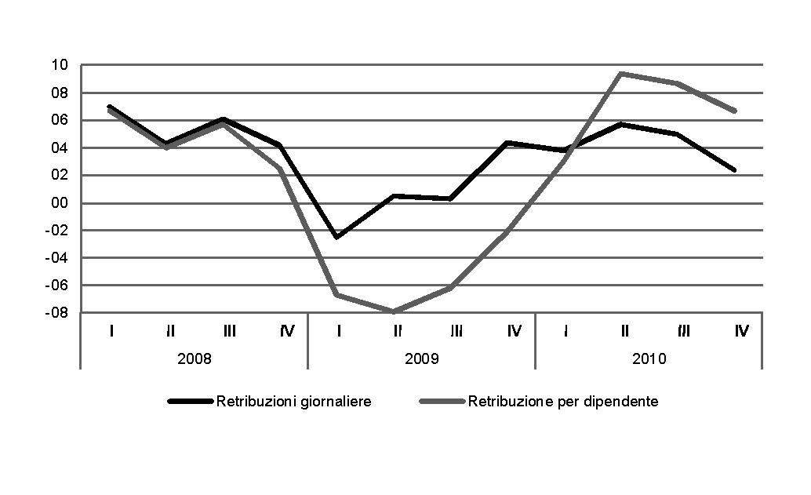
Source: Add the appropriate source (with a detailed description if necessary)
(a) Include possible explanatory notes for the figure content, if necessary.

Text text text text text text text text text text text text text text text text text text text text text text text text text text text text text text text text text text text text text text text text text:
- text;
- text.
Text text text text text text text text text text text text text text text text text text text text text text text text text:
- text;
- text.
Text text text text text text text text text text text text text text text text text text text text text text text text text text text text text text text text text text text text text text text text text:
(1.1)
Text text text text text text text text text text text text text text text text text text text text text text text text text text text text text text text text text text text text text text text text text.
Table 1.1 – Title of the table
Arial (a) | 7 pt. | Arial | 7 pt.
Arial 7 pt. | Arial 7 pt. | Arial 7 pt. | Arial 7 pt.
Arial 7 pt. | Arial 7 pt. | Arial 7 pt. | Arial 7 pt.
Arial 7 pt. | Arial 7 pt. | Arial 7 pt. | Arial 7 pt.
Arial 7 pt. | Arial 7 pt. | Arial 7 pt. | Arial 7 pt.
Arial 7 pt. | Arial 7 pt. | Arial 7 pt. | Arial 7 pt.
Arial 7 pt. | Arial 7 pt. | Arial 7 pt. | Arial 7 pt.
Source: Add the appropriate source (with a detailed description if necessary)
(a) Include possible explanatory notes for the figure content, if necessary.

References
Eurostat. 2004. How Europeans spend their time. Everyday life of women and men: data 1998-2002. Luxembourg: Statistical Office of the European Communities.
Fitoussi, J-P, K. Malik, J. Rubery, and R. Skidelsky. 2021. “Putting people first: Beyond COVID-19”. Rivista di statistica ufficiale/Review of official statistics, N. 2/2021: 7-27. Roma, Italy: Istat. https://www.istat.it/en/archivio/265347.
International Monetary Fund - IMF. 2019. Macroeconomics of aging and policy implications. Group of twenty. Washington, D.C., U.S.: IMF.

Istituto Nazionale di Statistica – Istat. 2019. “Essere anziani oggi: non è solo una questione di età”. In Rapporto Annuale 2019. La situazione del Paese. Roma, Italy: Istat. https://www.istat.it/it/archivio/230897.

Istituto Nazionale di Statistica – Istat. 2019. “Rapporto SDGs 2019. Informazioni statistiche per l’Agenda 2030 in Italia”. Letture Statistiche – Temi. Roma, Italy: Istat. https://www.istat.it/it/archivio/229565.

Sen, A.K. 1985. “Well-being, Agency and Freedom: The Dewey Lectures 1984”. The Journal of Philosophy, Volume 82, N. 4: 169-221.
Stiglitz, J.E. 2015. The Great Divide: Unequal Societies and What We Can Do About Them. New York City, NY, U.S.: W.W. Norton & Company.
Sudman, S., D.K. Willimack, E. Nichols, and T.L. Mesenbourg. 2000. “Exploratory Research at the U.S. Census Bureau on the Survey Response Process in Large Companies”. Proceedings of the Second International Conference on Establishment Surveys: 327-337. Alexandria, VA, U.S.: American Statistical Association.
Warr, M., and C.G. Elison. 2000. “Rethinking social reactions to crime: Personal and altruistic fear in family households”. American Journal of Sociology, Volume 106, Issue 3: 551-78.
Zaidi, A., S. Harper, K. Howse, G. Lamura, and J. Perek-Biała (eds.). 2018. Building Evidence for Active Ageing Policies. Active Ageing Index and its Potential. London, U.K.: Palgrave Macmillan.

Professional position and affiliation, e-mail:...
Professional position and affiliation, e-mail:....
Acknowledgements and Attributions (if necessary): The authors thank… etc. Though the article is the result of a joint work, the single paragraphs are attributed as follows: paragraph 1, 2 and 3 to Name Surname; paragraph 4, 5 and Appendix A to Name Surname etc. The views and opinions expressed are those of the authors and do not necessarily reflect the official policy or position of the Italian National Institute of Statistics - Istat.
For the construction of the Figures prefer grayscale tables. Texts/Numbers within the Figures should be typed in 7 pt. Arial font. Figures should be framed, with a width of 13 cm. (same as the text box). Figures should also be included as a separate .xls file, with the original size and data.
Tables should have a width of 13 cm. (the same as the text box). Texts/Numbers within the Tables should be typed in 7 pt. Arial font. Tables should always be also included as a separate file with the original size and data.
References should follow the Author-Date format of the Chicago Manual of Style. More in detail, list all referenced items alphabetically by author, then by year of publication beginning with the most recent year. Use italics for titles of books and journals. It is necessary to always include all the bibliographic references used within the text: in round brackets (Author’s Surname, Year, page number/s). The examples listed in the present template are the most frequently used: an institution as a book author, an article by multiple authors, an article on a journal, etc. For further details, refer to https://www.chicagomanualofstyle.org/tools_citationguide/citation-guide-1.html.

